**Introduction**

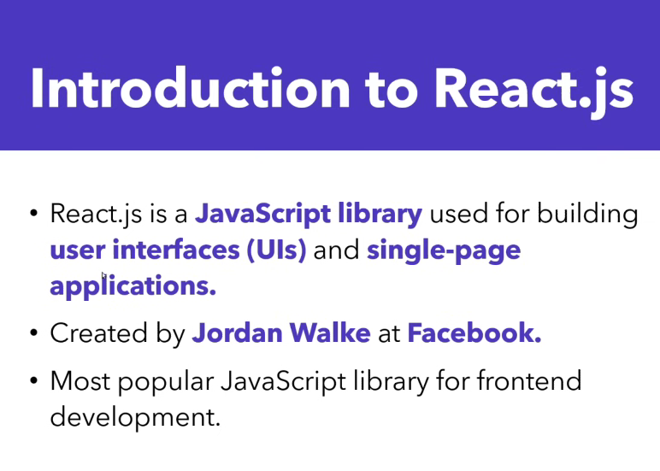

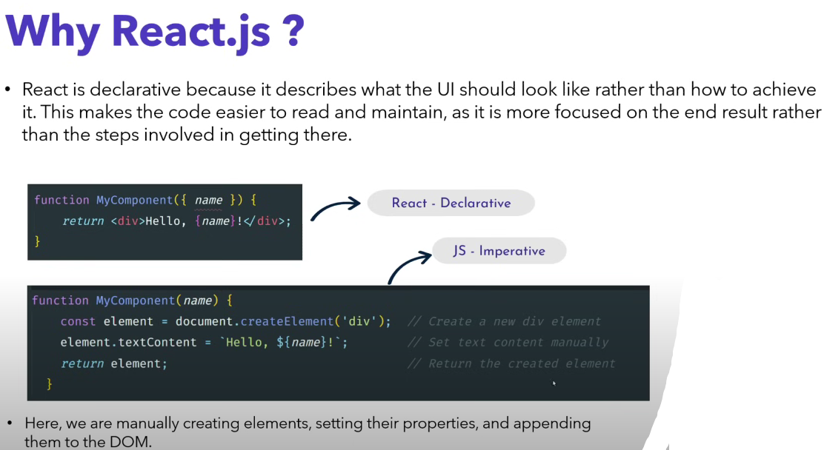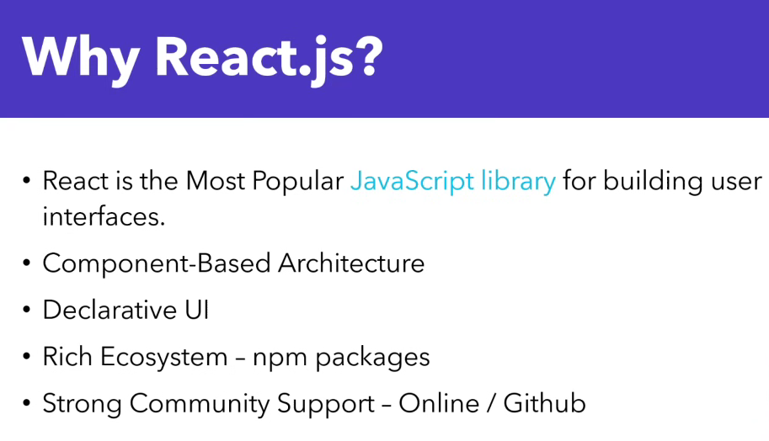

**Installation**

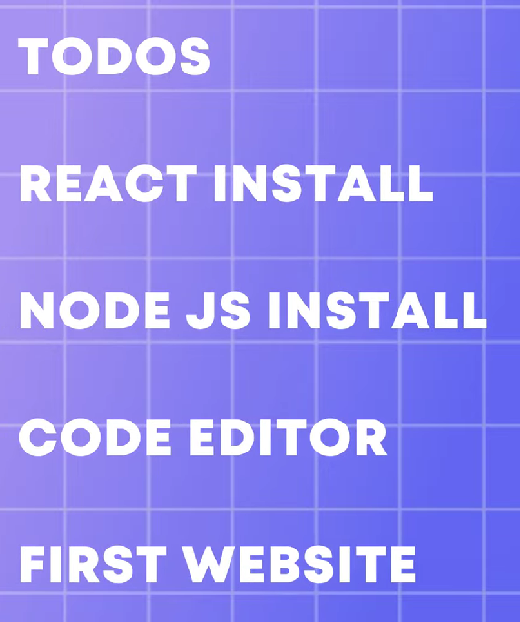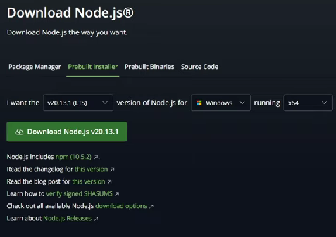

**–Node Js**

Node allows developers to write JavaScript code that runs directly in a computer process itself instead of in a browser.

Node.js is a cross-platform, open-source JavaScript runtime environment that can run on Windows, Linux, Unix, macOS, and more. Node.js runs on the V8 JavaScript engine, and executes JavaScript code outside a web browser. Node.js lets developers use JavaScript to write command line tools and for server-side scripting.

**Bydefault npm installed with node**

**–Bun - package manager**

Develop, test, run, and bundle JavaScript & TypeScript projects—all with Bun.   
  
Bun is an all-in-one JavaScript runtime & toolkit designed for speed, complete with a bundler, test runner, and **Node.js-compatible package manager.**

<https://bun.sh/>



**npm i -g bun**

**Why we use bun 👇**

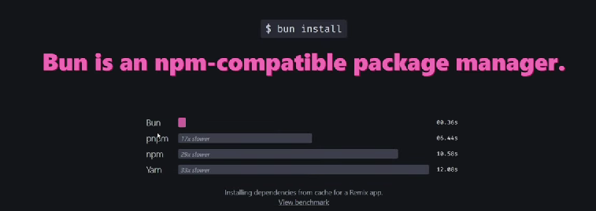

Bun is fast because it uses the JavaScriptCore engine, while Node. js uses the JavaScript V8 engine. The former has been optimised for faster startup time. If you want to get things done faster, you should consider replacing Node.

**–Vite Js**

**After that install Vite Js**

<https://vitejs.dev/guide/>

Vite JS is majorly used to set up a development environment for various frameworks like React and Vue.

**bun create vite**

Then follow next steps to create react app

Run app

bun run dev

**Successfully created react app 👇**

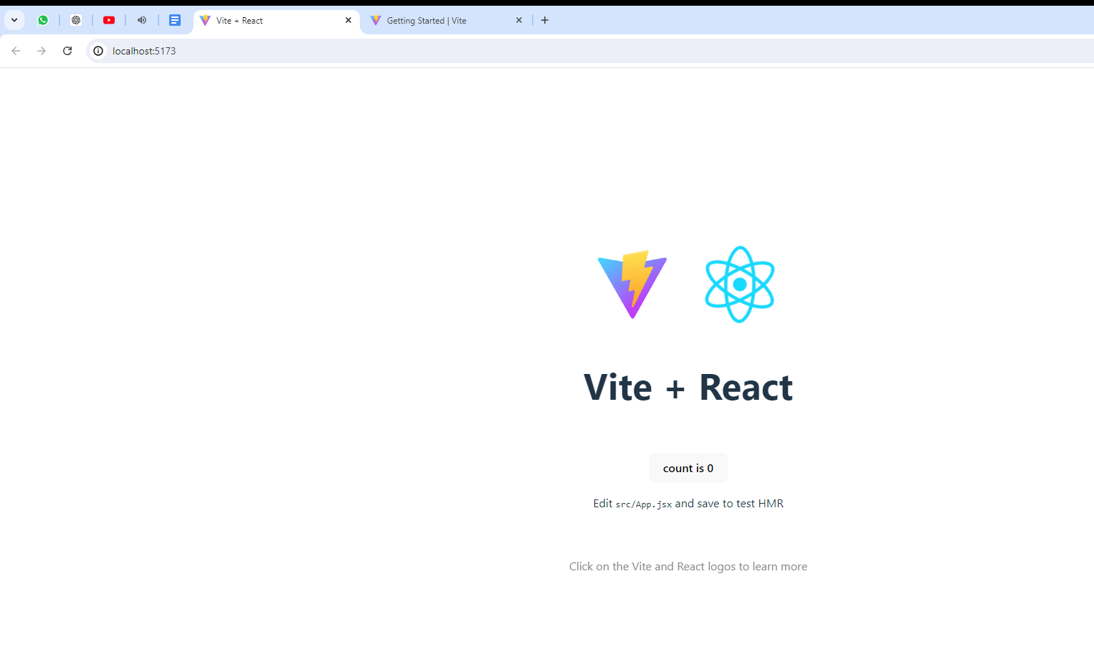

**Useful commands**

For install latest react version 19 remove dependencies 18 something

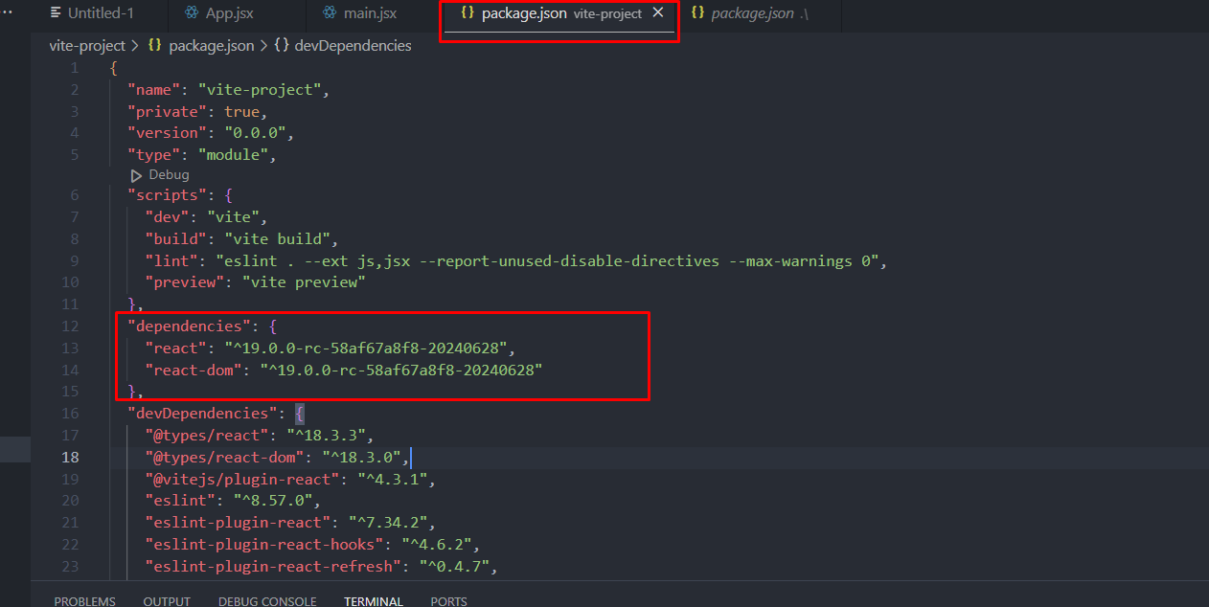

Then run following command 👇

bun install react@rc

bun i react-dom@rc

**Prerequisites**

Before learning ReactJs, It is essential to understand **HTML, CSS, and JavaScript.**

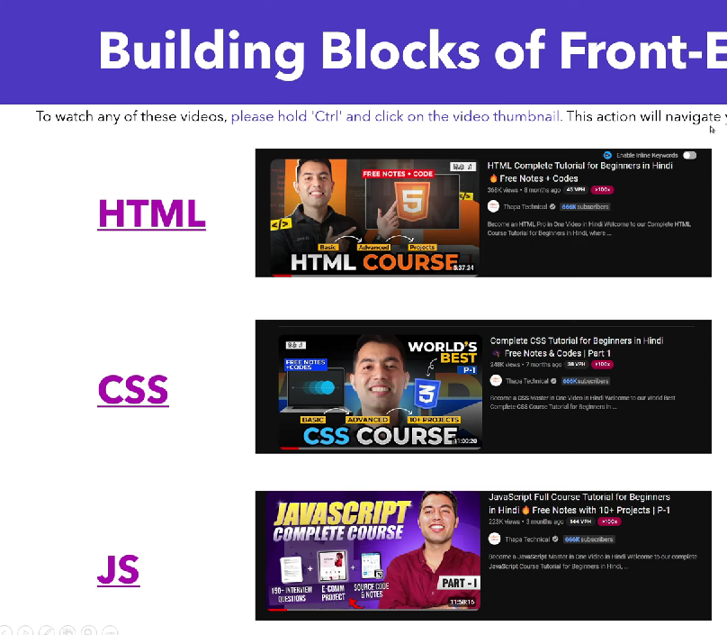

**Folder Structure**

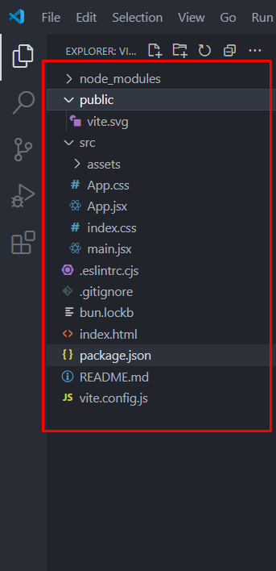

**– 1 Node modules**

The node_modules directory is where all the dependencies packages are stored that are used to build and run your react project.

**– 2 Public**

This folder contains all the static files like images, videos and font etc..

**– 3 Src**

This folder contains all the source files

–React Components in .jsx files

–Javascript

–CSS

**– 4 eslintrc.cjs**

In a React project, the . eslintrc. cjs file is a configuration file used to set the rules for ESLint. ESLint is a popular JavaScript code linter that helps developers identify issues within their code, maintaining code quality and consistency.

**– 5 gitignore**

The .gitignore file is used to specify which files and directories Git should ignore in a project. This is useful for excluding temporary files, build artifacts, dependency directories, and other files that should not be committed to the repository.

**– 6 index.html**

The main HTML file where your react application is loaded, serving as the entry point for the web browser.

**– 7 package.json**

The package.json file in a React app is a crucial component that contains metadata about the project and manages its dependencies, scripts, and configuration.

**React + React DOM** for websites

**React + React Native** for Mobile App

**Naming Conventions**

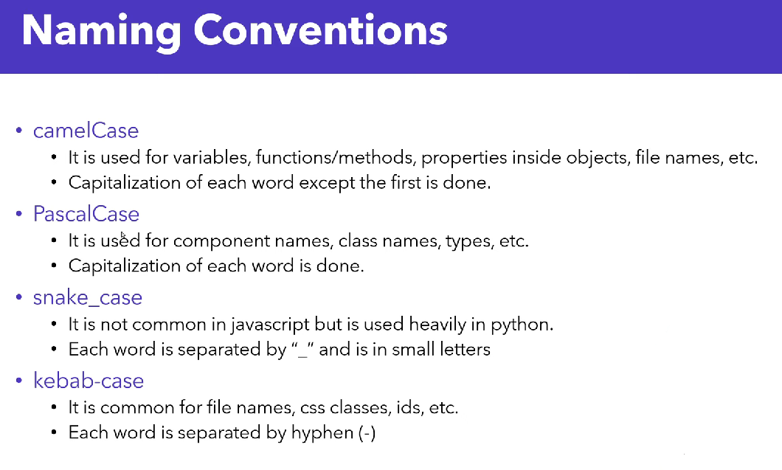

**Jsx - JavaScript XML**

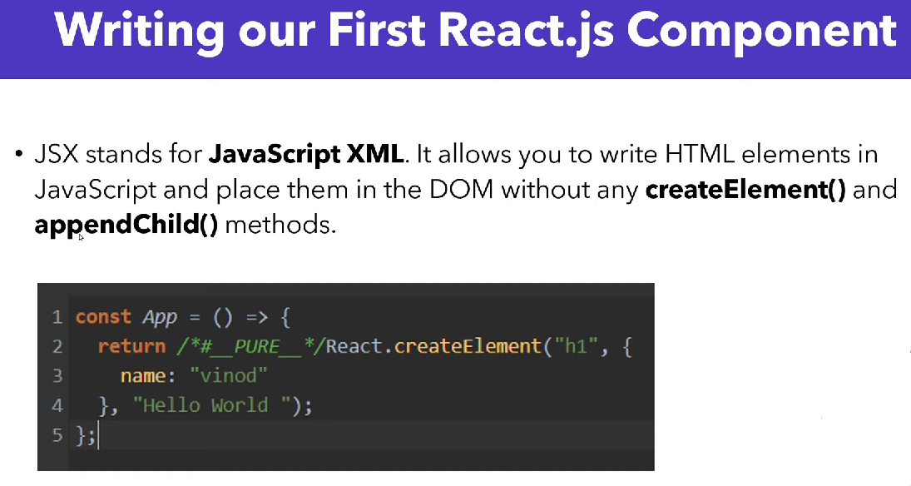**Does Babel convert JSX to JS?**

Browsers don't understand JSX out of the box, so most React users rely on a compiler like Babel or TypeScript to transform JSX code into regular JavaScript

**React has installed babel by default 👇**

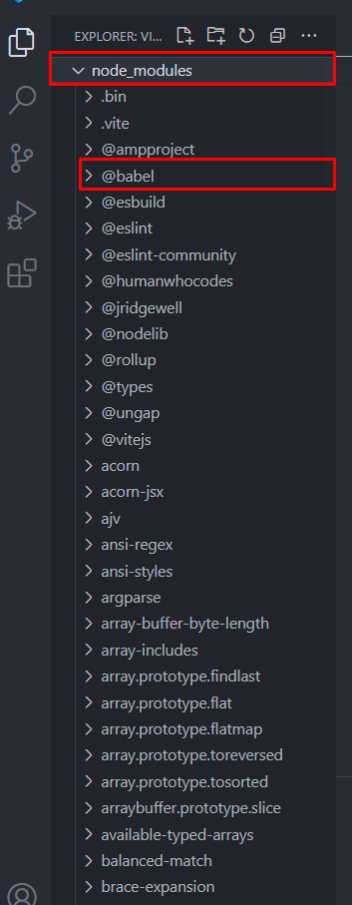

**Component**

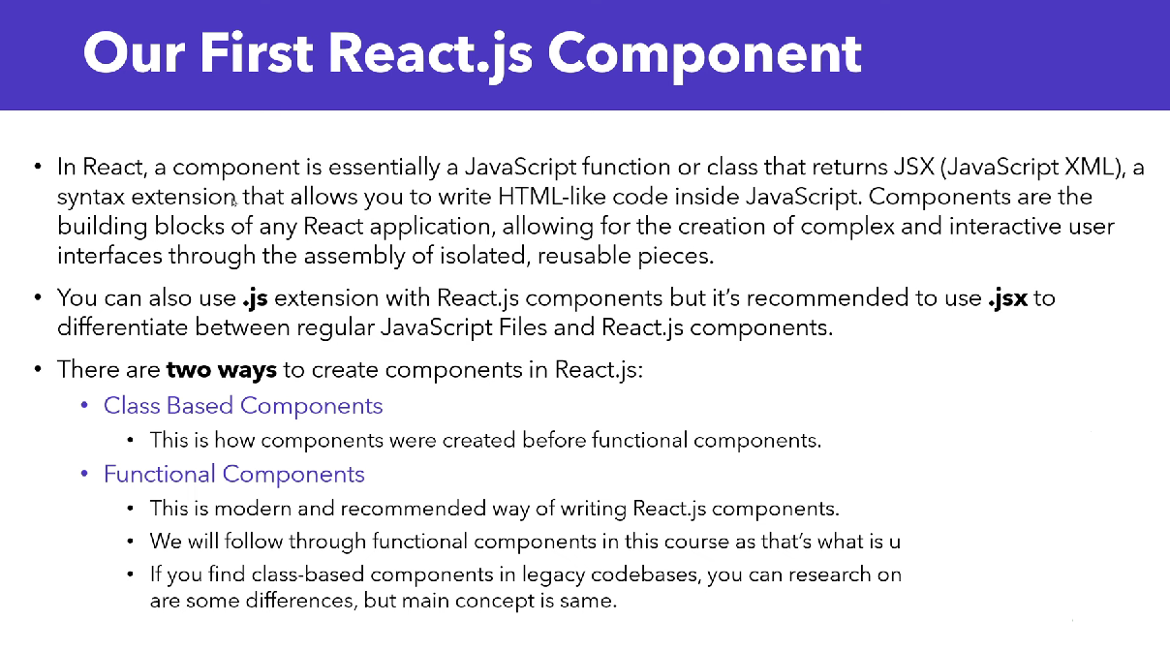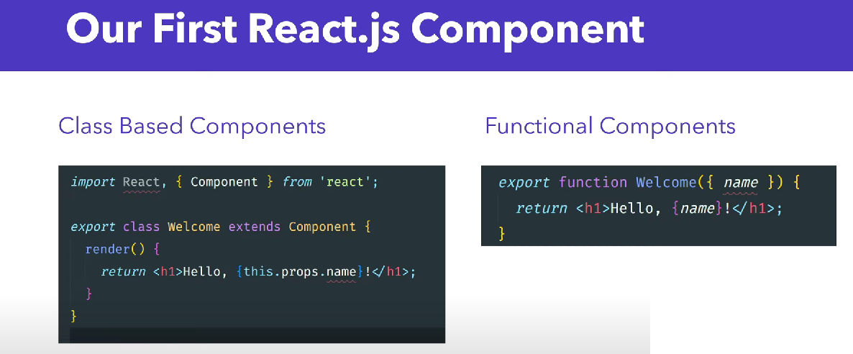

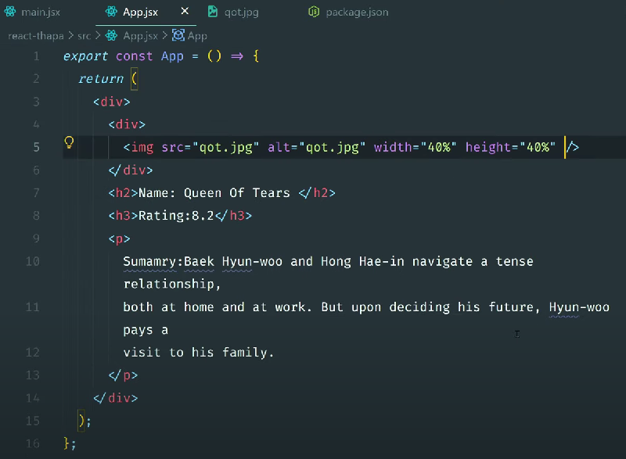

**React Fragment**

A common pattern in React is for a component to return multiple elements.   
Fragments let you group a list of children without adding extra nodes to the DOM.

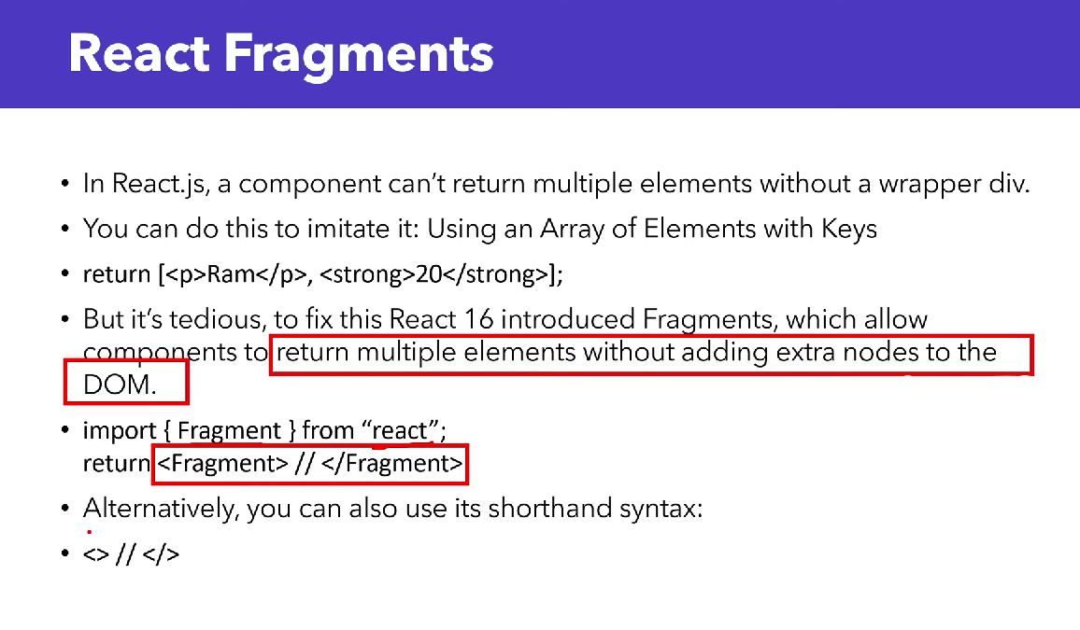

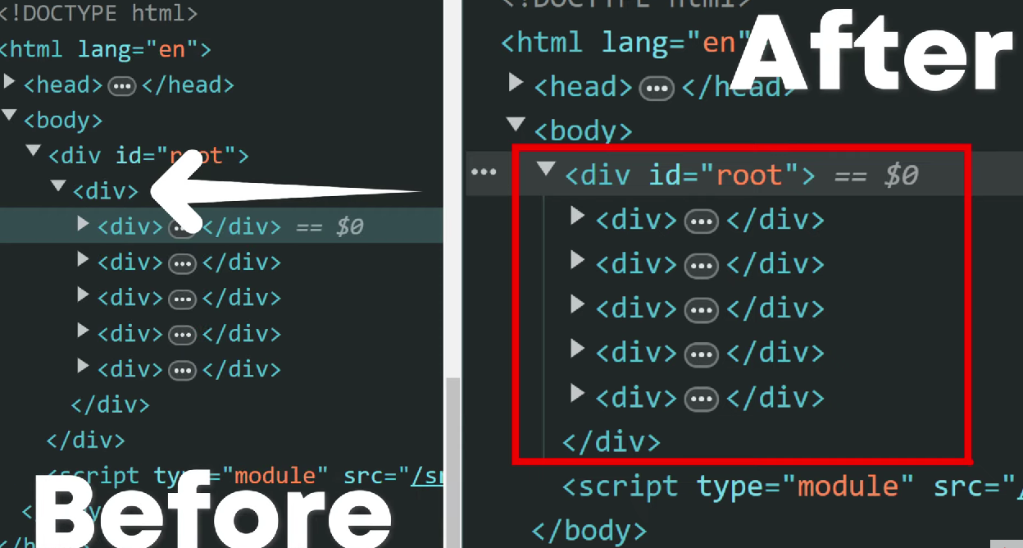

**Dynamic values in JSX**

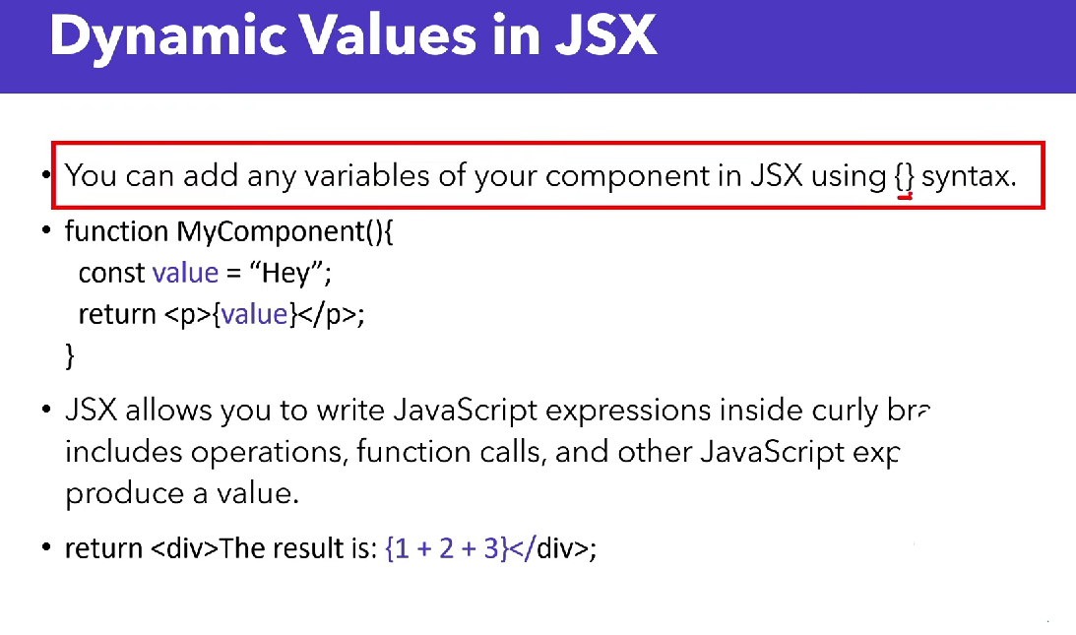



**Import and export**

<https://react.dev/learn/importing-and-exporting-components>

**Looping in JSX**

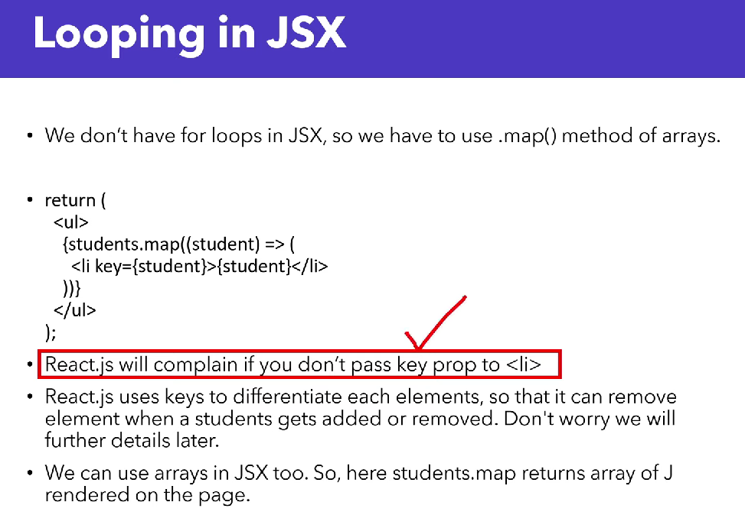

**Props in JSX**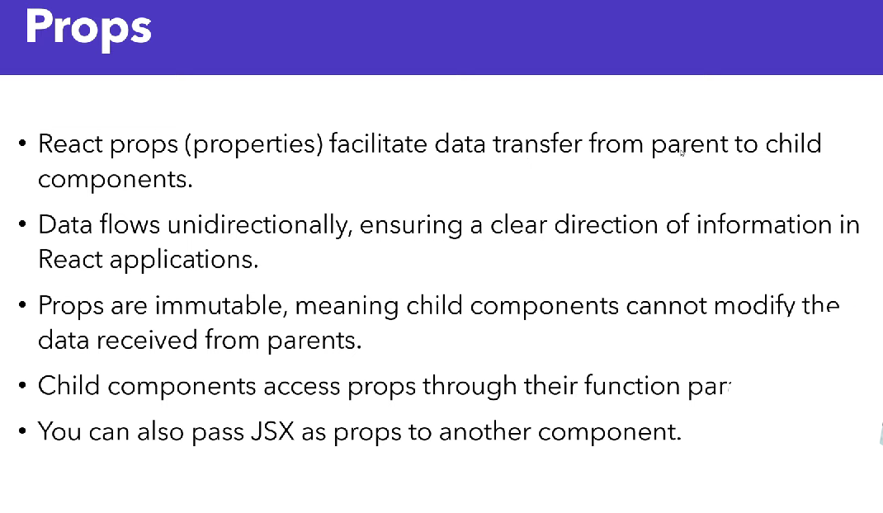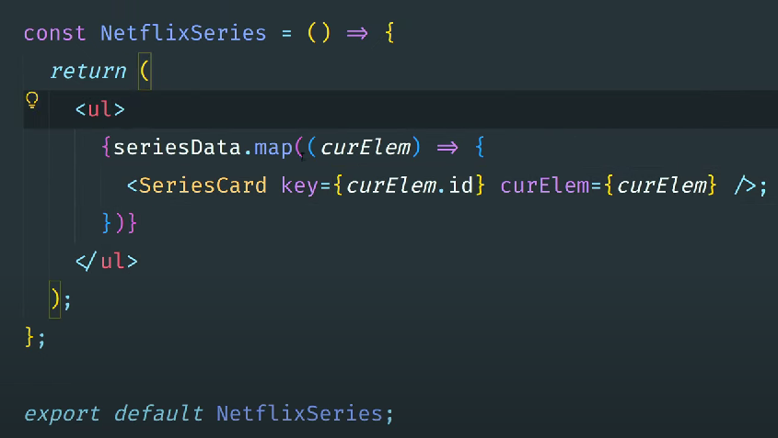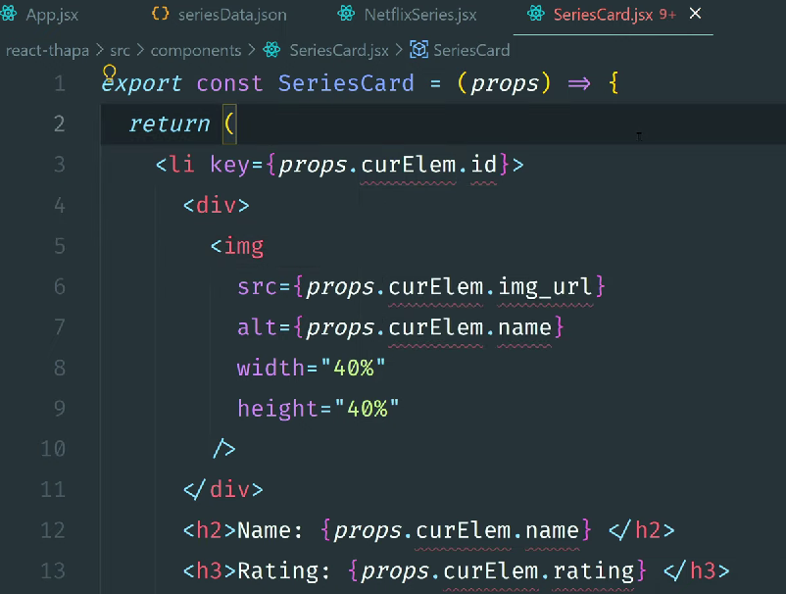

**Destructuring Props in JSX**

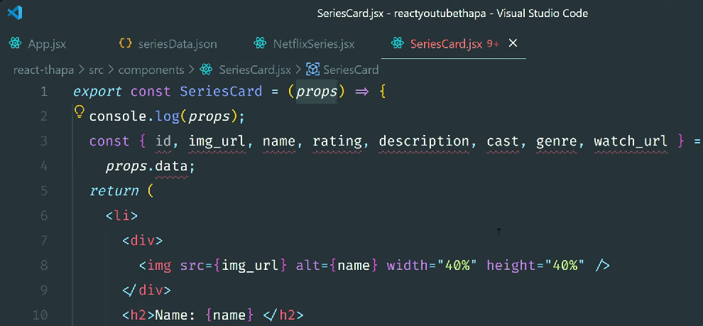

**– accept props in curly {} braces 👇**

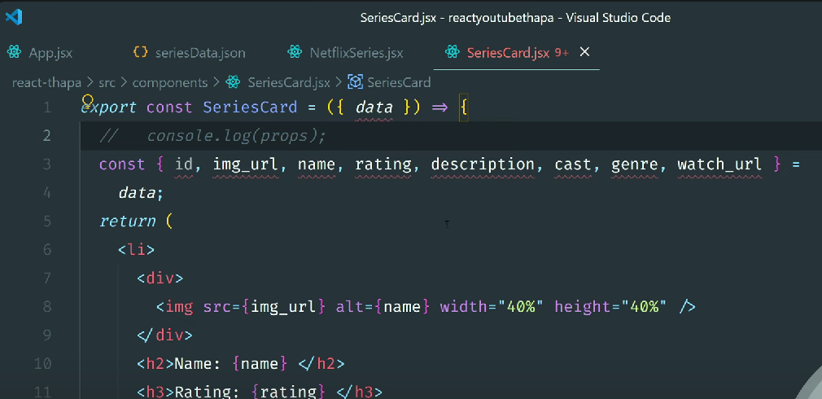

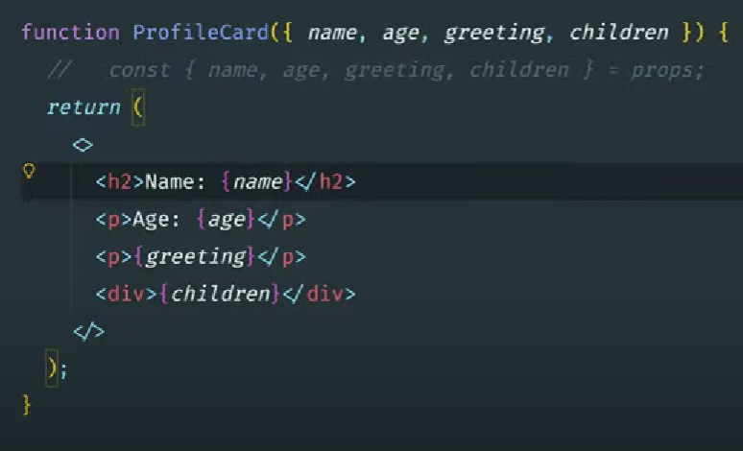

**How to Deal with Errors and Warnings👇**

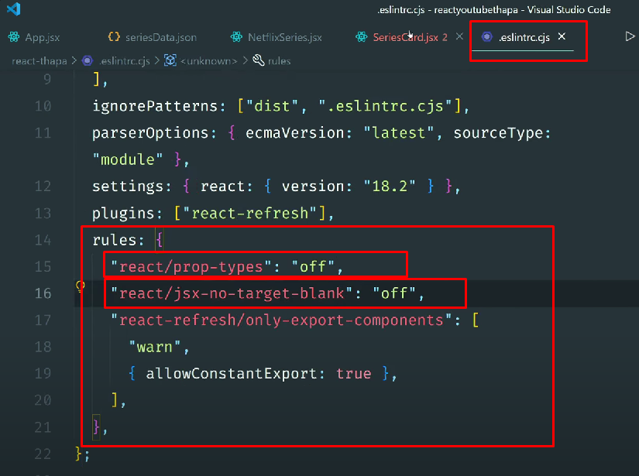

**Pass JSX as props👇**

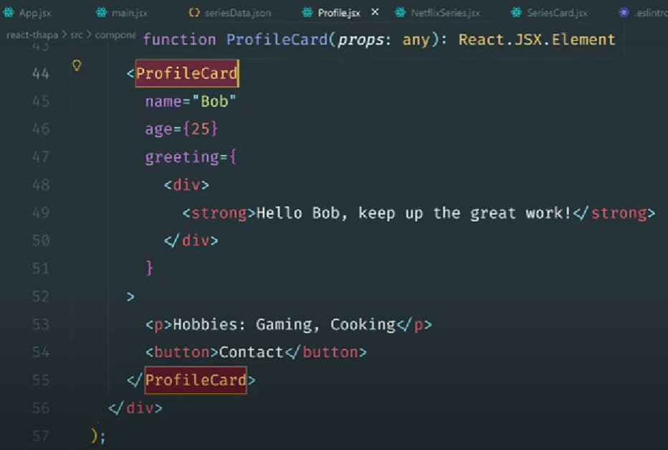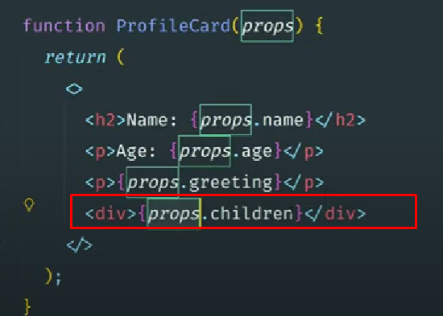

**Add CSS Styling in React: Class vs ClassName👇**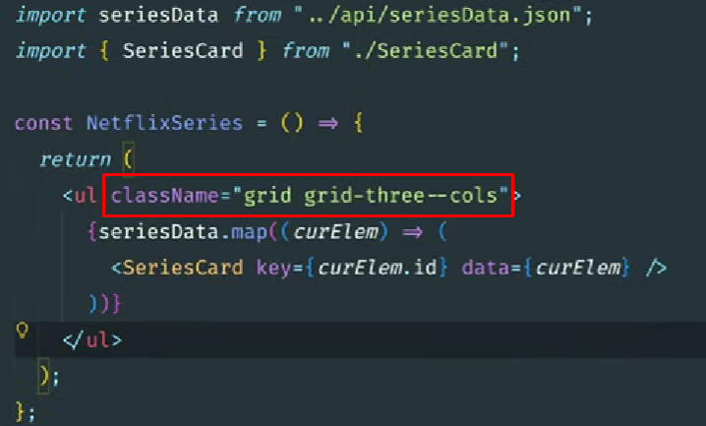

**–inline CSS 👇**

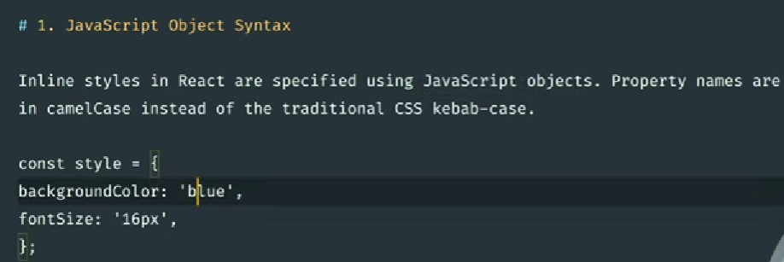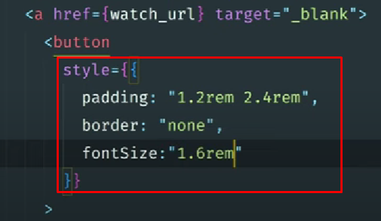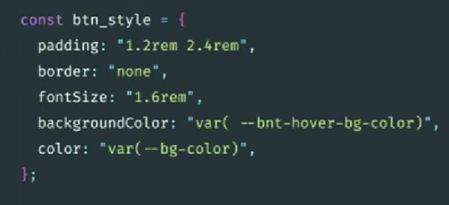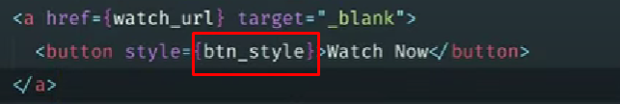

**Add conditional style👇**

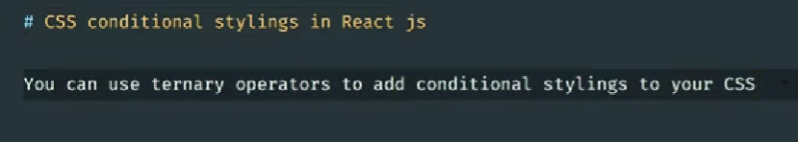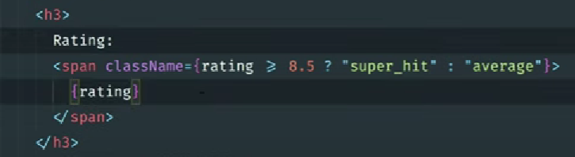

**Multiple classes with conditional class 👇**

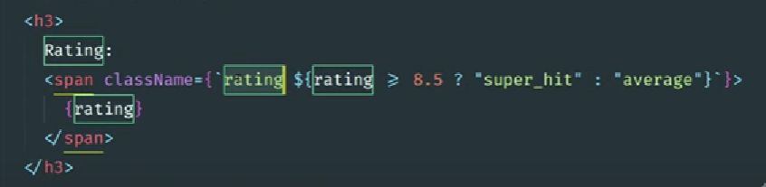

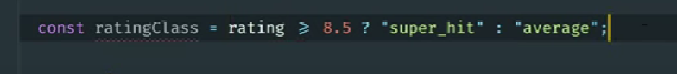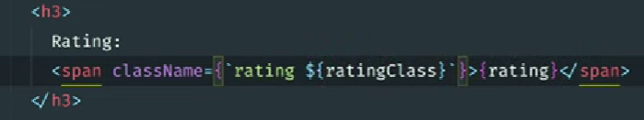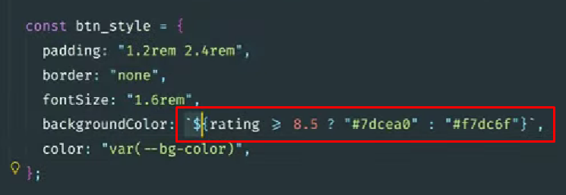

**CSS Modules in React: Scoped and Reusable Styles👇**

**Create separate css file for specific component and import in particular component**

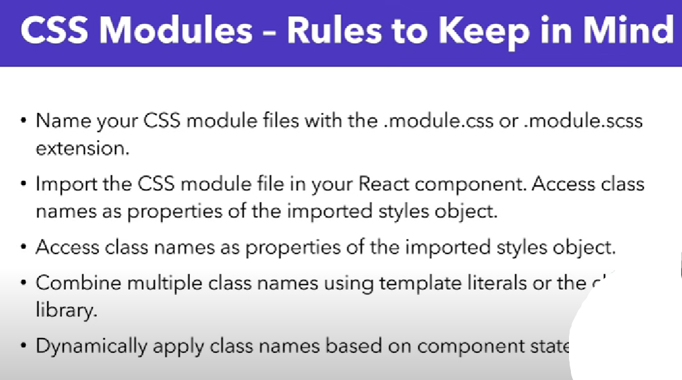

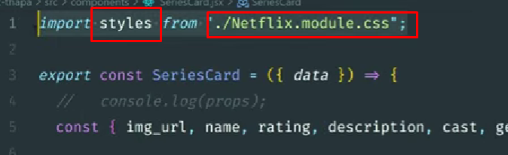

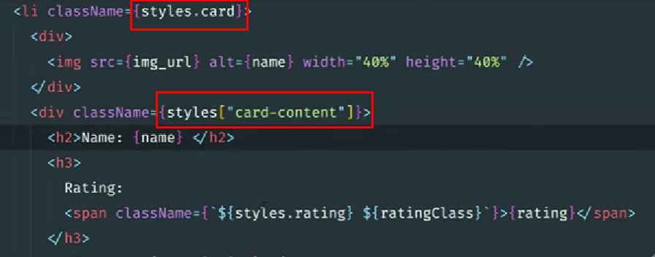

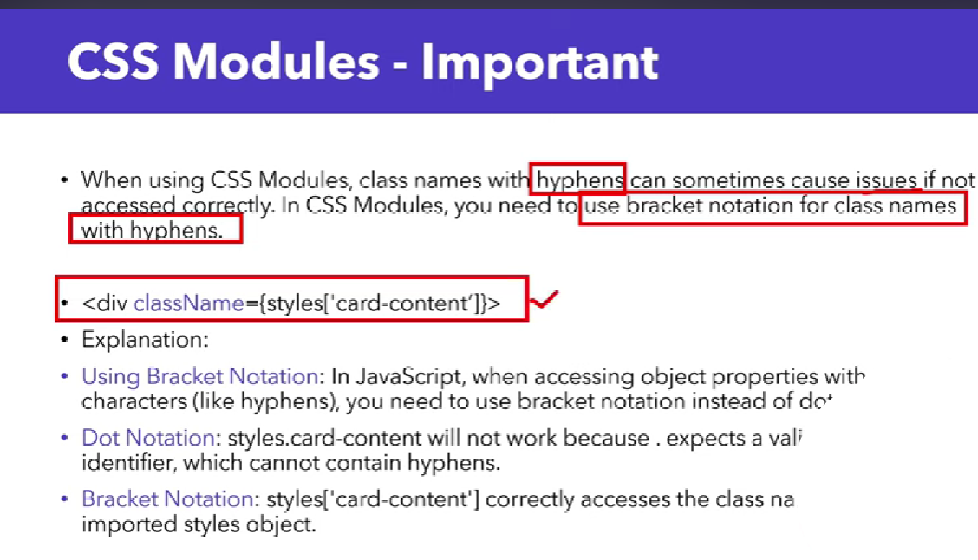

**Using CSS modules changes class names to unique class names on the front-end to prevent conflicts between the same classes used throughout the app.**

**For more info 👉** [**https://css-tricks.com/css-modules-part-1-need/**](https://css-tricks.com/css-modules-part-1-need/)

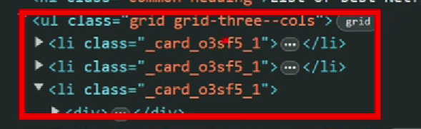

**Events Handling 👇**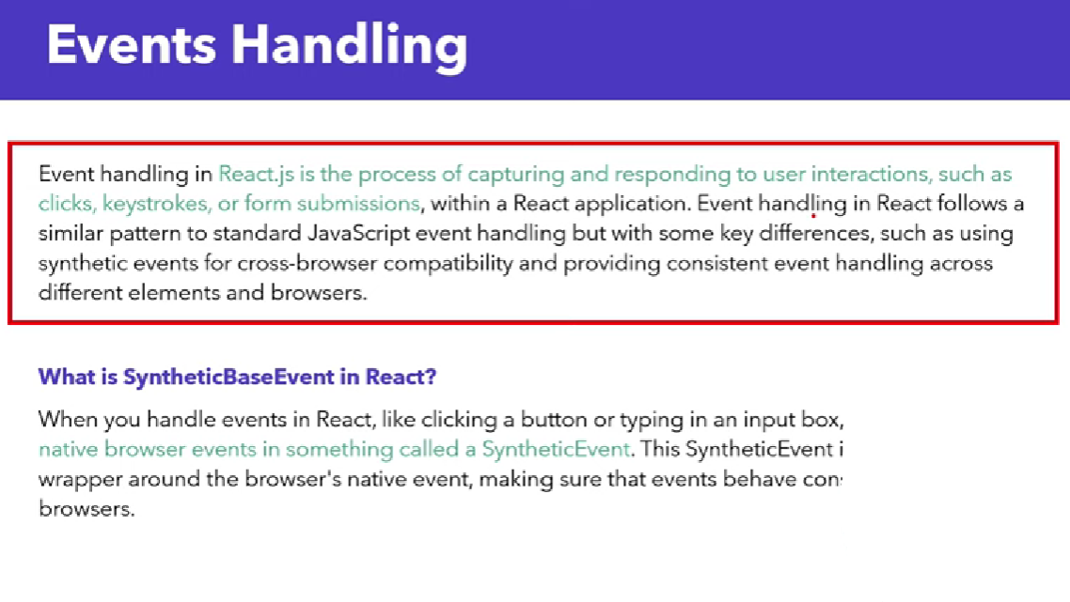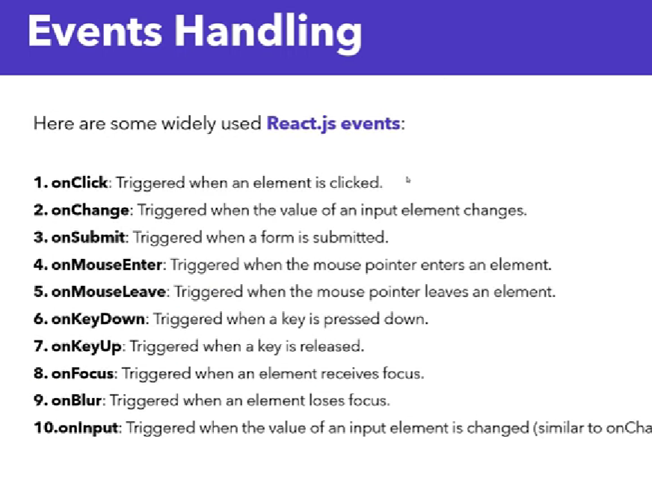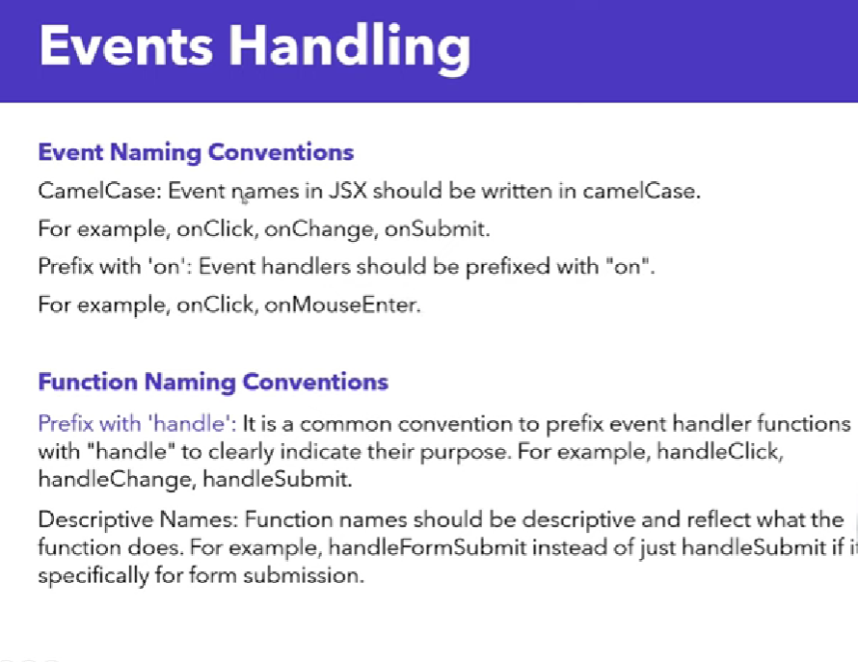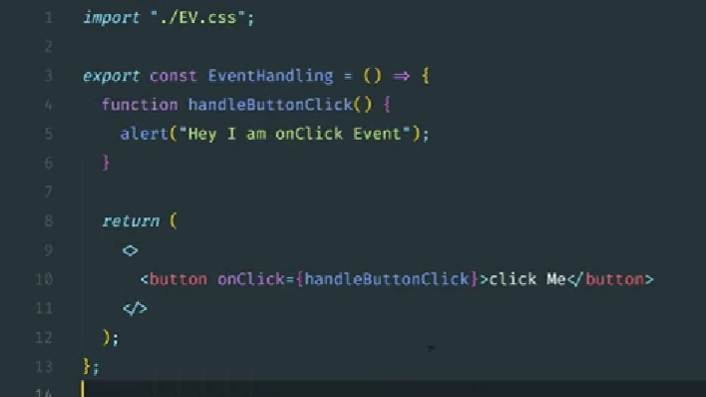

**Function calling with name and fat arrow function 👇**

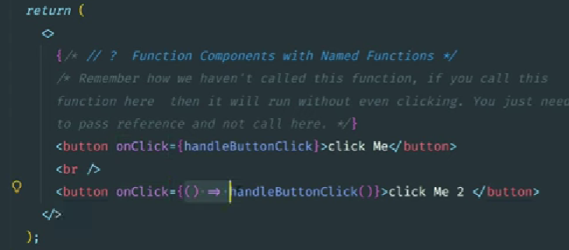

**Passing Events as Props in React | Control Parent Function Using Child Component 👇**

**Parent 👇**

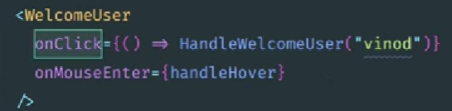

**Child 👇**

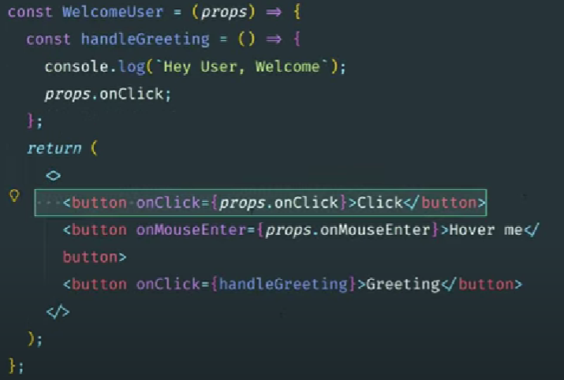

**Destructuring 👇**

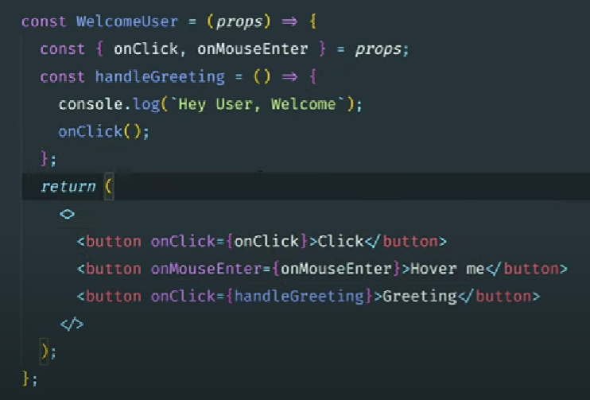

**Event Propagation 👇**

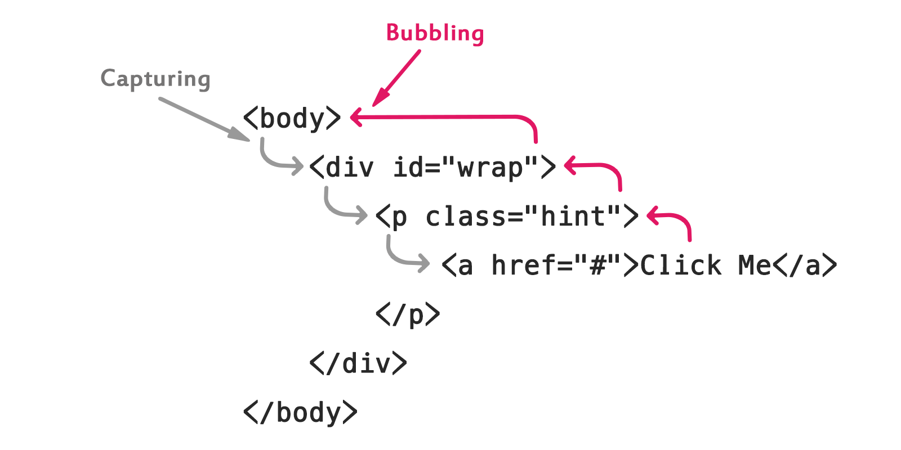

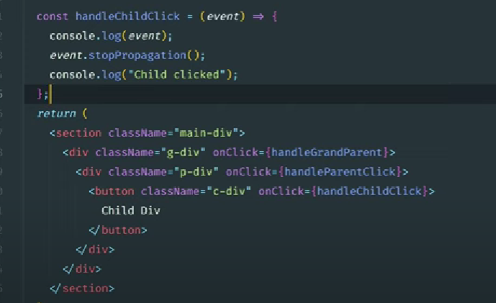

**Event Capture phase in react 👇**

**onClickCapture(your function here)**

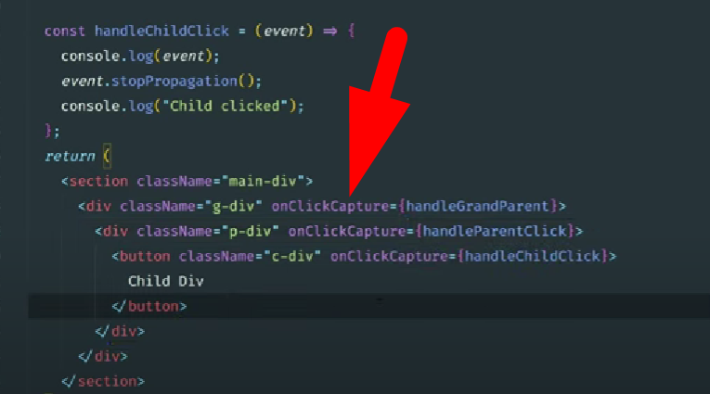

**States 👇**

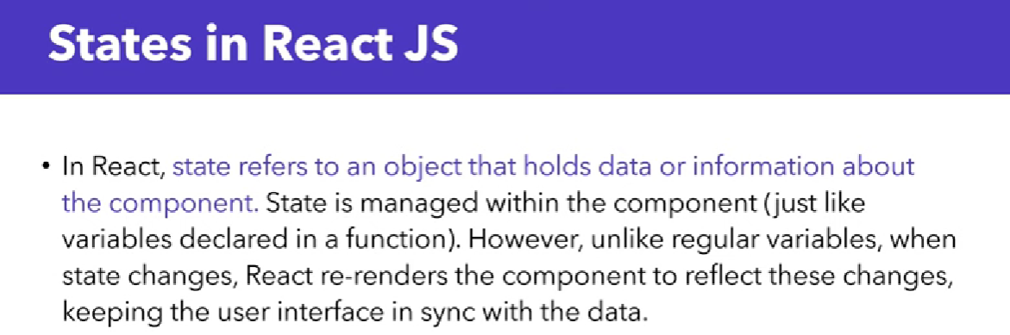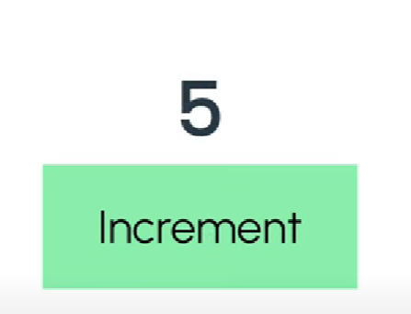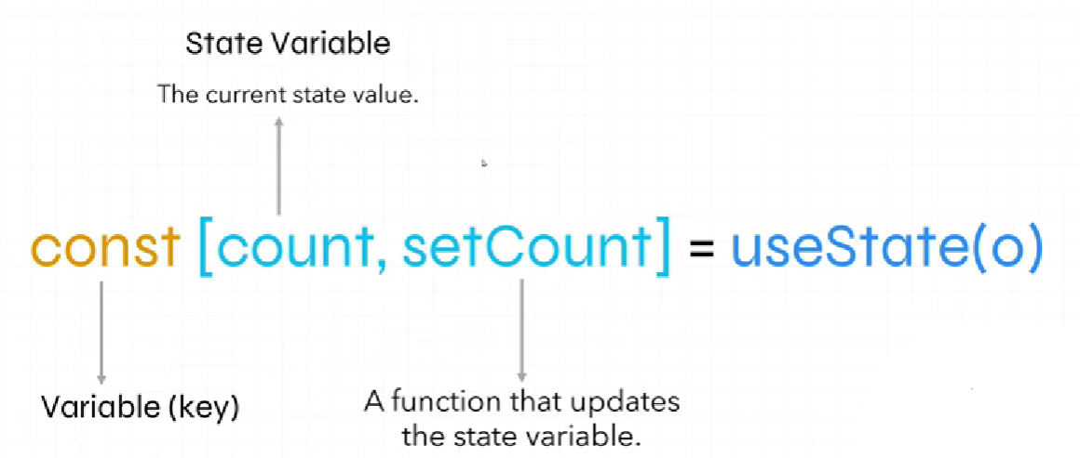

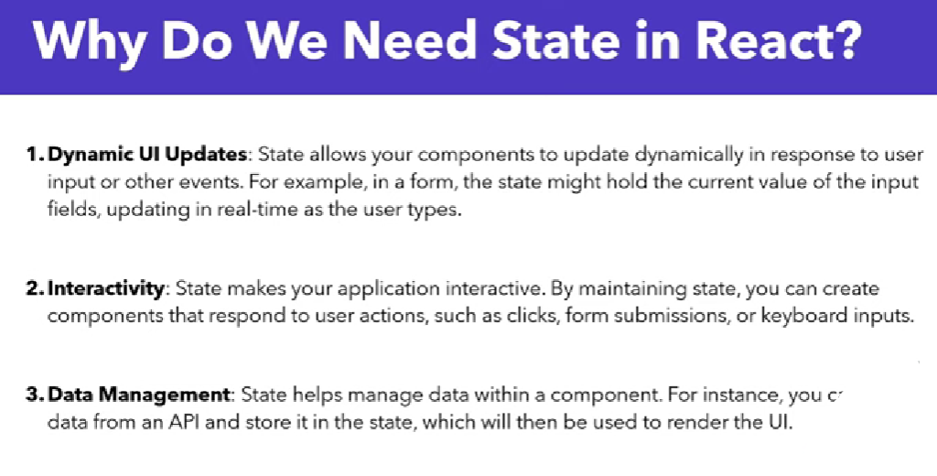

**Lifting the state up**

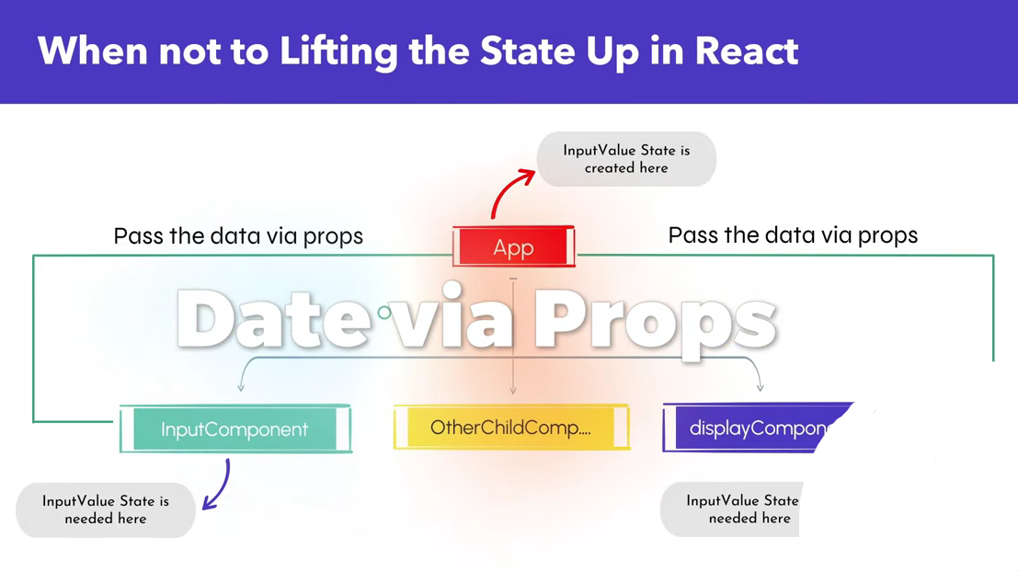

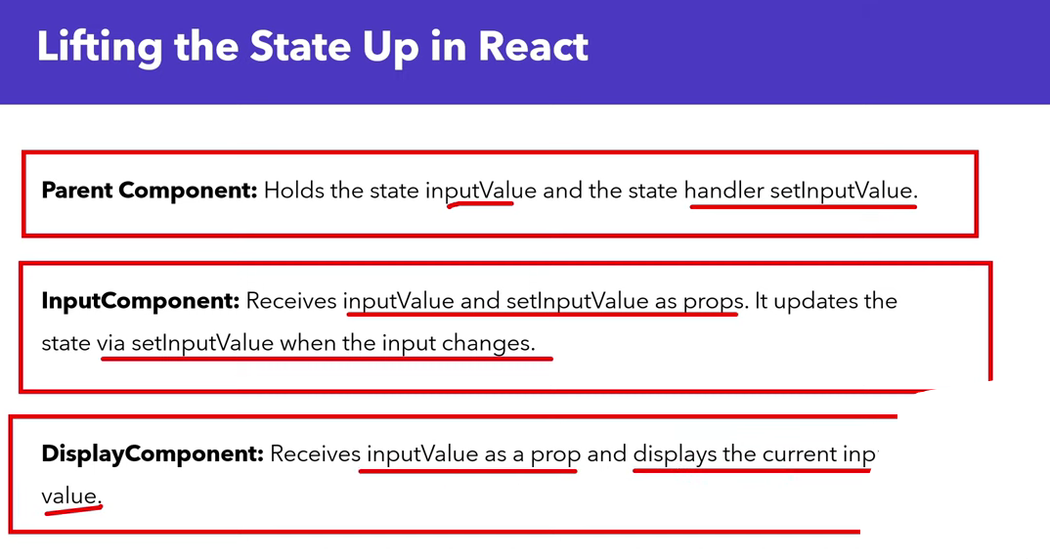

**App.jsx 👇**

**import { useState } from "react";**

**import ParentCom from "./ParentCom";**

**import ChildCom from "./ChildCom";**

**export const App = () => {**

**let [count, updateCount] = useState(0);**

**return (**

**<>**

**<ParentCom *count*={count} *updateCount*={updateCount} />**

**<ChildCom *count*={count} />**

**</>**

**)**

**}**

**ParentCom.jsx 👇**

**function ParentCom(*props*) {**

**return (**

**<>**

**<h1>{*props*.count}</h1>**

**<button *onClick*={() => *props*.updateCount(*props*.count + 1)}>Click me</button>**

**</>**

**)**

**}**

**export default ParentCom;**

**ChildCom.jsx 👇**

**function ChildCom(*props*) {**

**return (**

**<>**

**<p>Your count is {*props*.count}</p>**

**</>**

**)**

**}**

**export default ChildCom;**

**Toggle Switch**

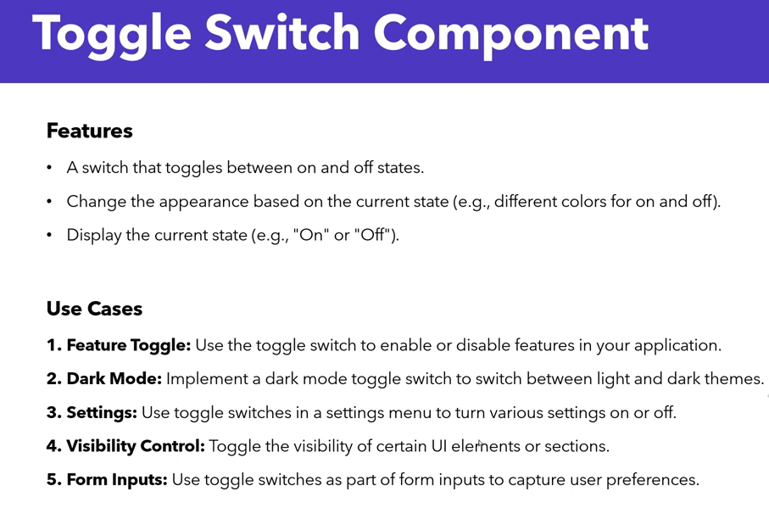

import { useState } from "react"

export const ToggleSwitch = () => {

const [isOn, setIsOn] = useState(false);

return (

<>

<p>{isOn ? "On" : "Off"}</p>

<label *className*={`switch ${isOn ? "On" : "Off"}`} *onClick*={() => setIsOn(!isOn)}>

<span *className*="slider"></span>

</label>

</>

)

}

**More simplify 👇**

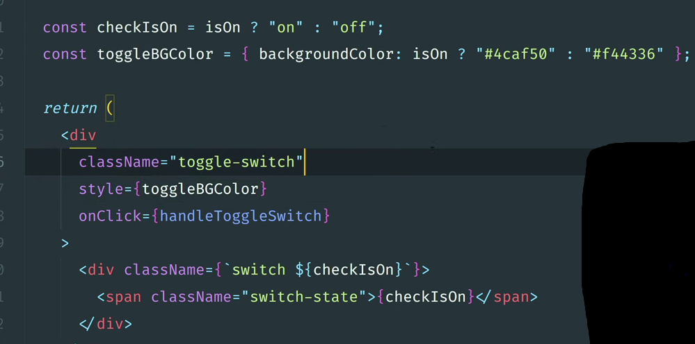

**React Icons**

<https://www.npmjs.com/package/react-icons>

**bun i react-icons**

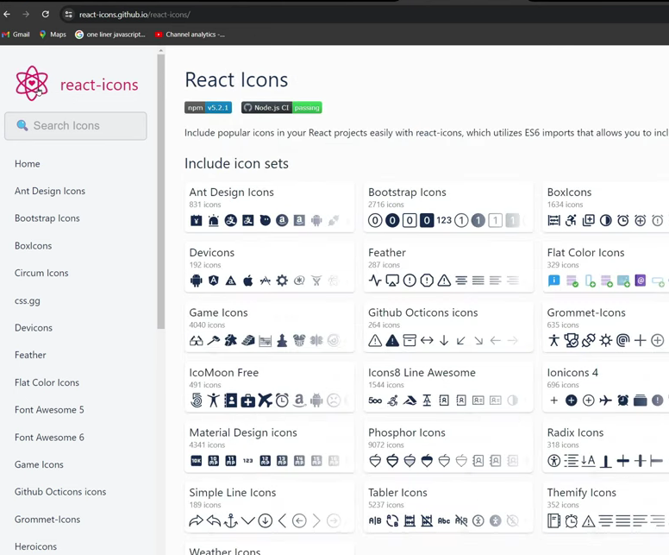

**UseEffect CleanUp**

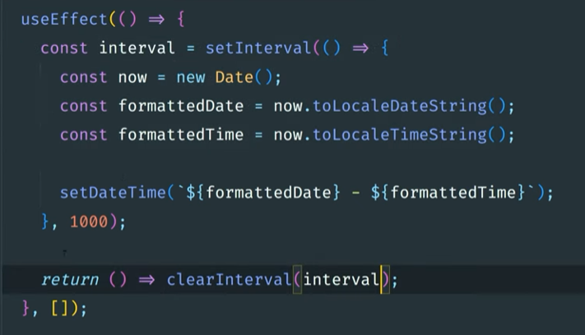

import { useState, useEffect } from "react"

export const DateTime = () => {

const [Time, SetTime] = useState(0);

useEffect(() => {

const timeInterval = setInterval(() => {

const d = new Date();

const time = d.toLocaleString();

console.log(time);

SetTime(time);

}, 1000);

return () => clearInterval(timeInterval);

}, [])

return (

<p>{Time}</p>

)

}

**ToDo App**

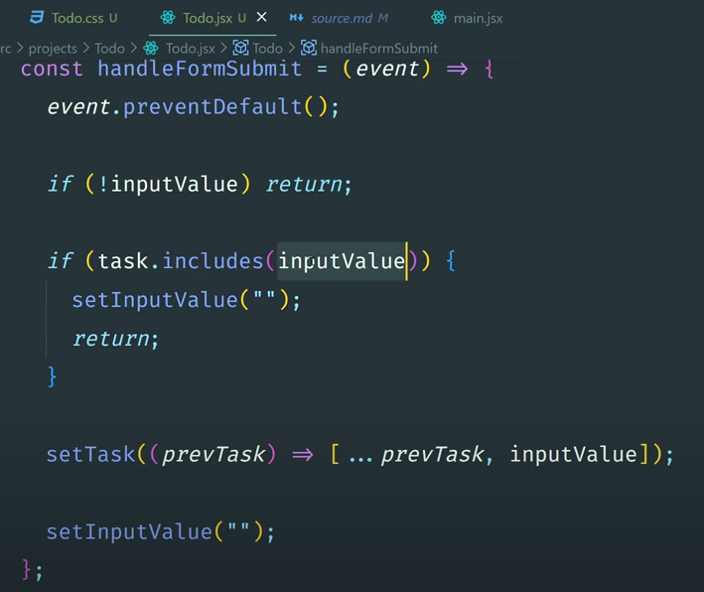

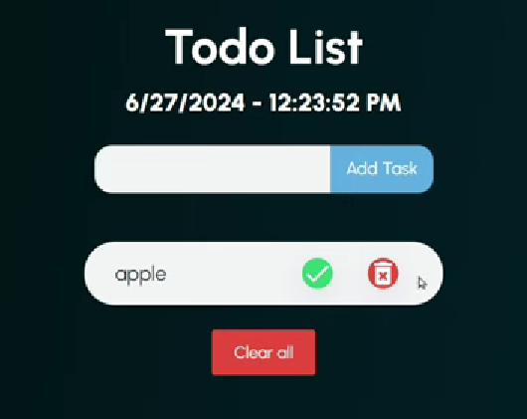

**After creating your TODO app, host it for free.**

First create a **production build** (version) from your development environment.

bun run build

**Live your app**

<https://app.netlify.com/login>

**Short Circuit Evaluation**

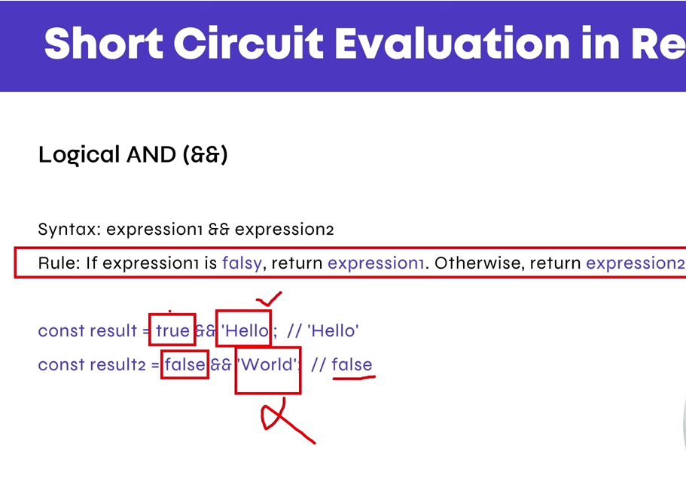

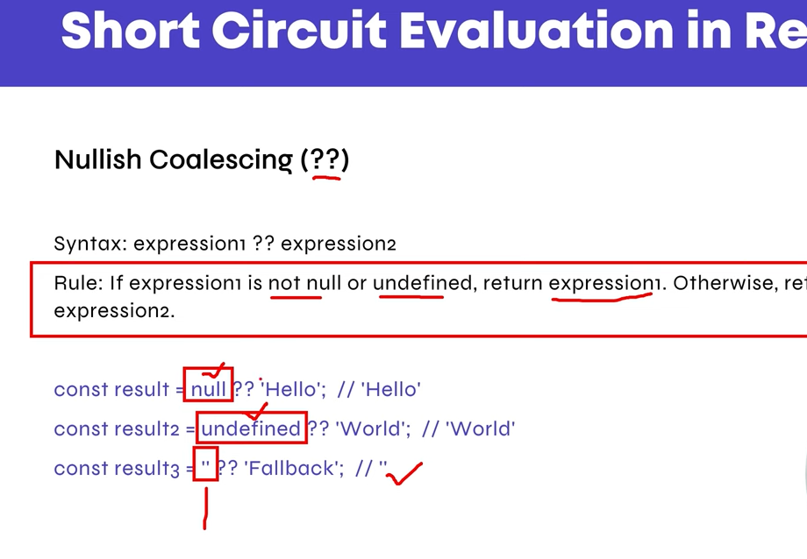

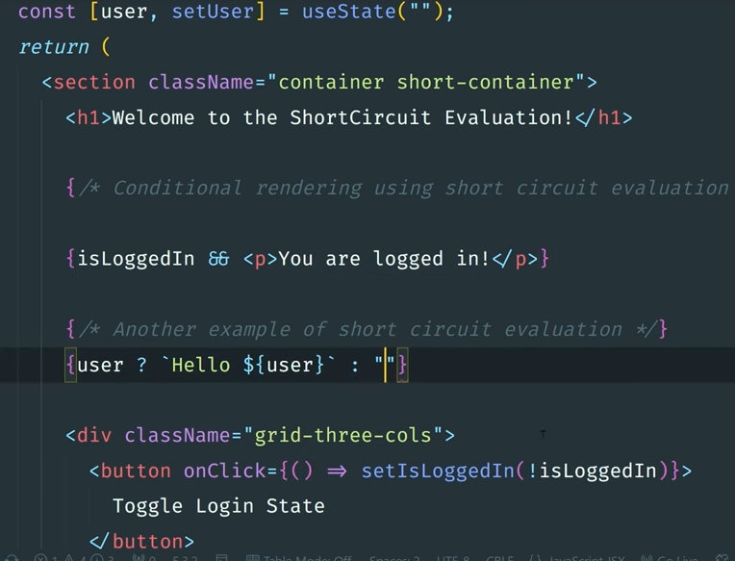

*// inputVal && "";*

*// !inputVal && alert("");*

*// if (!inputVal) return;*

!*inputVal* ? (alert("Please enter data"), false) : alert("Data added");

*// if (todoArr.includes(inputVal)) return;*

const isExistInArr = *todoArr*.find(*element* => {

return *element*.content == *inputVal*;

});

**Hooks Rules**

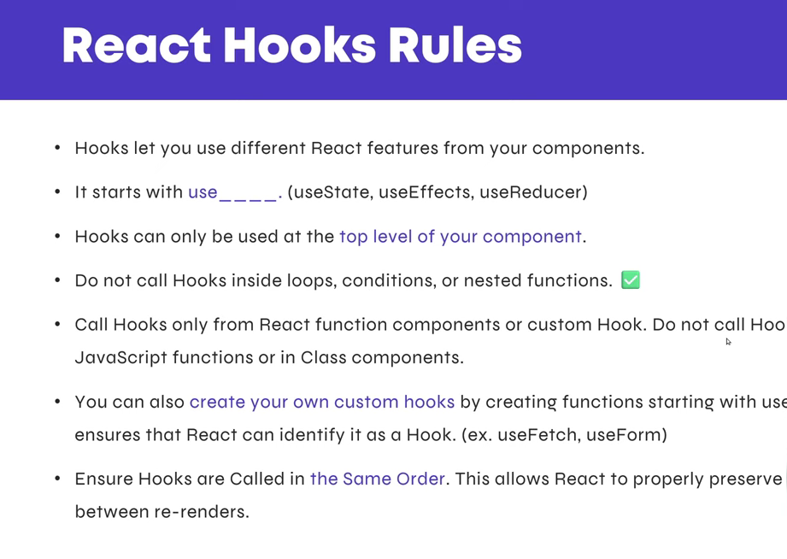

**useState Hook**

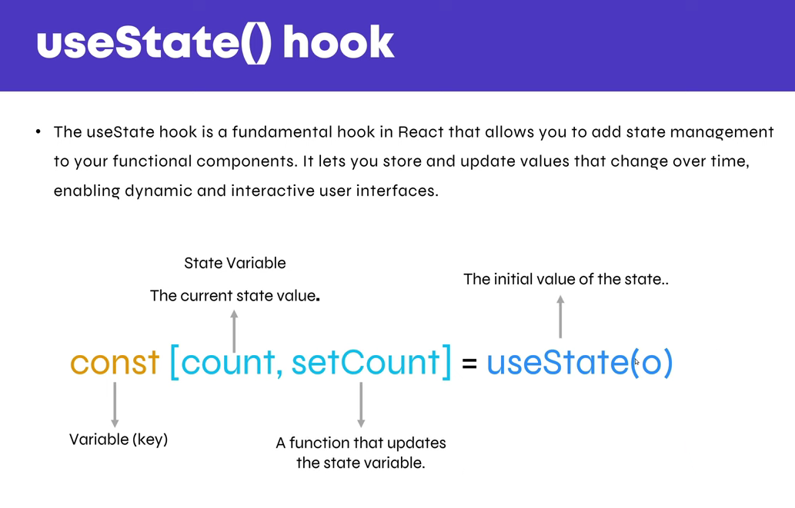

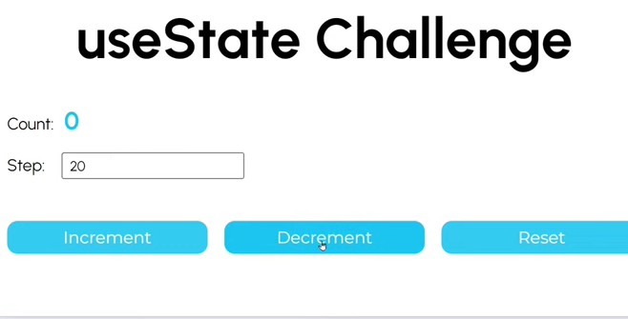

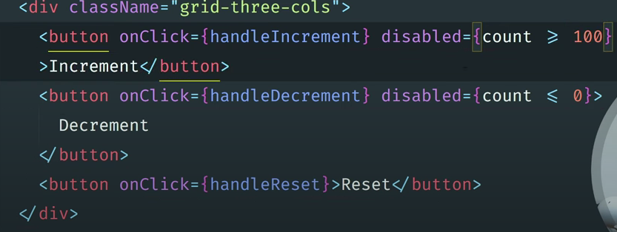

**Controlled Component**

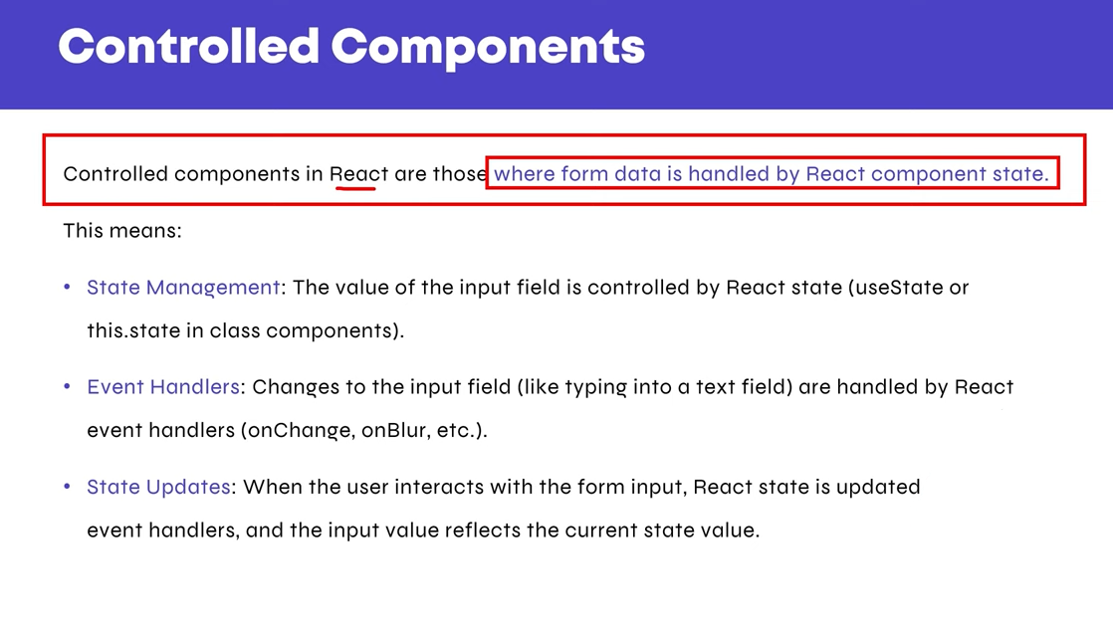

**UnControlled Component**

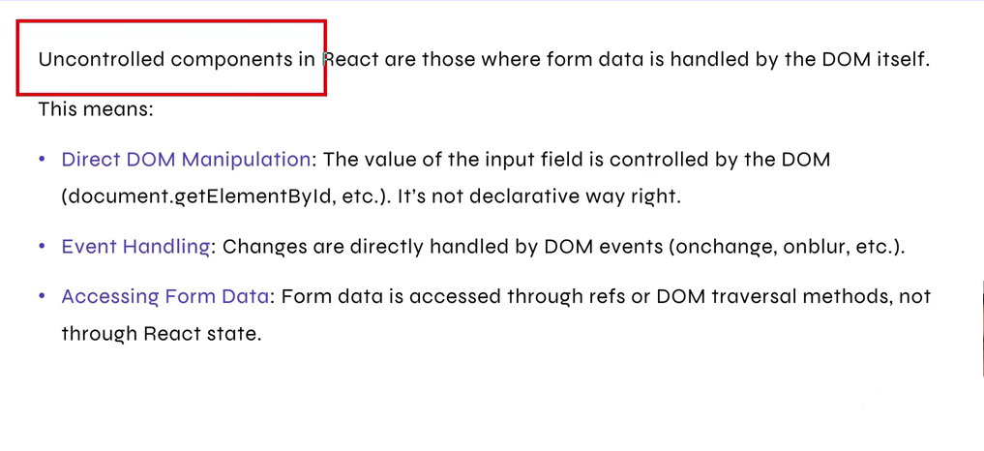

**Form Handling**

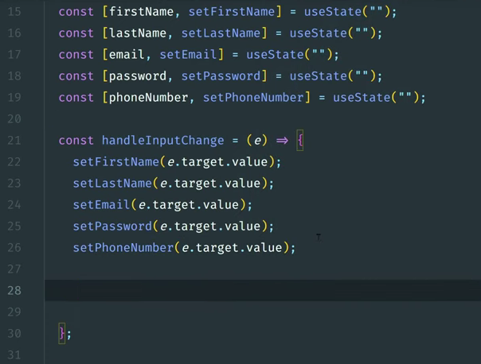

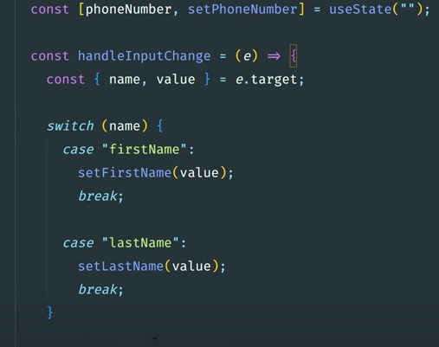

**Object**

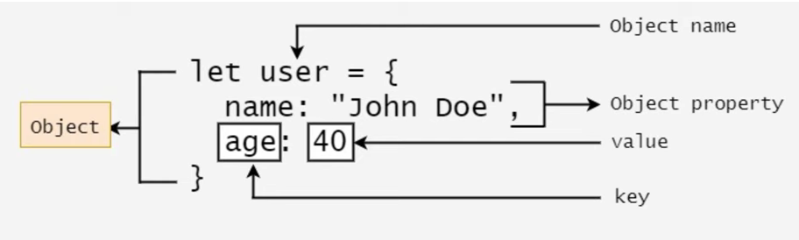

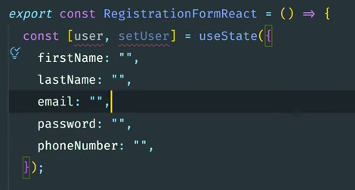

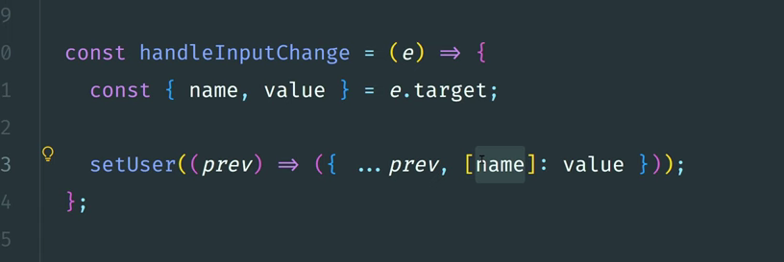

**Contact Form**

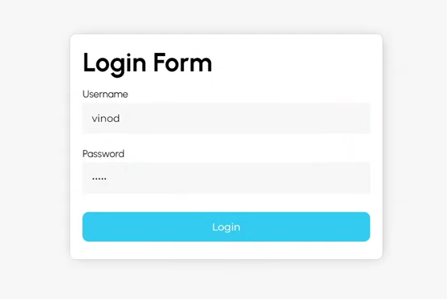

**useEffect Hook**

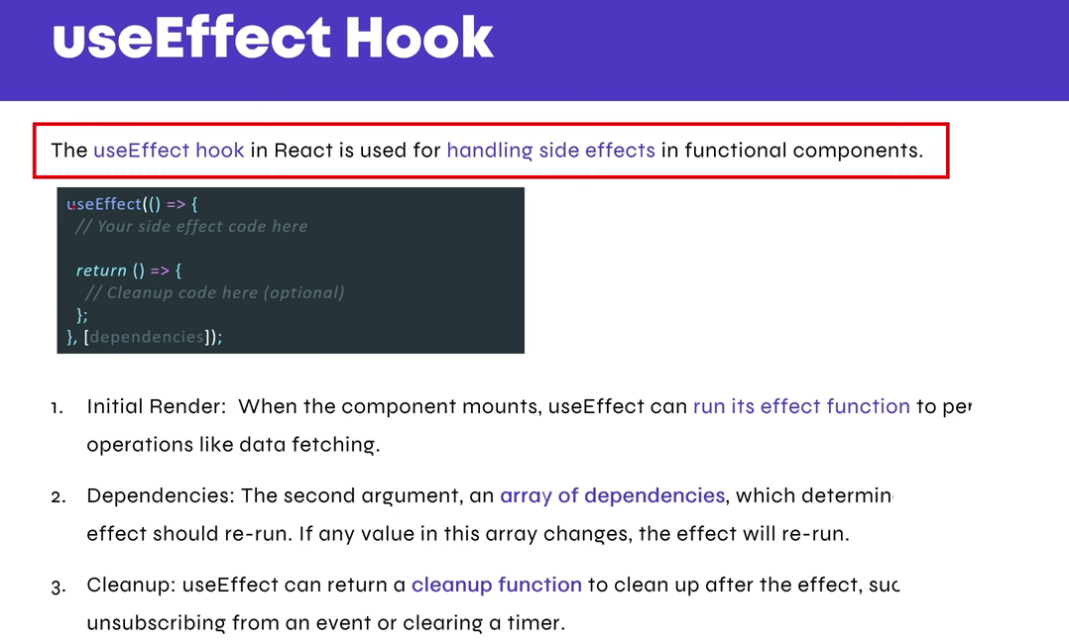

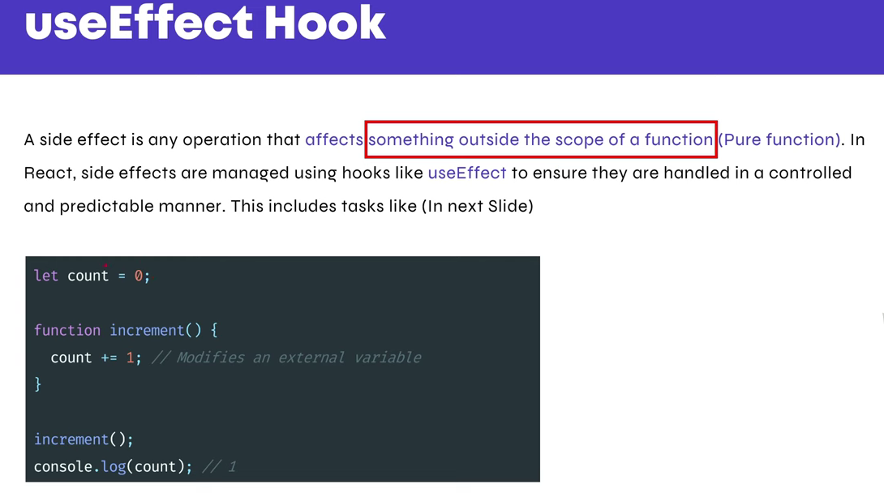

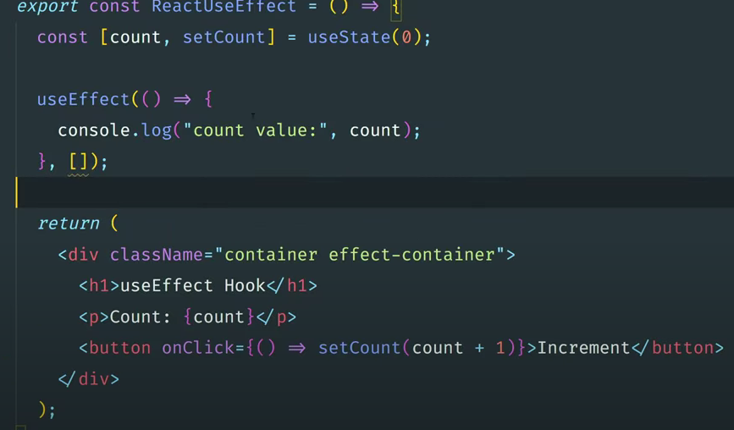

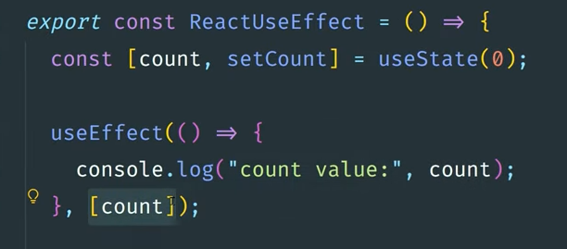

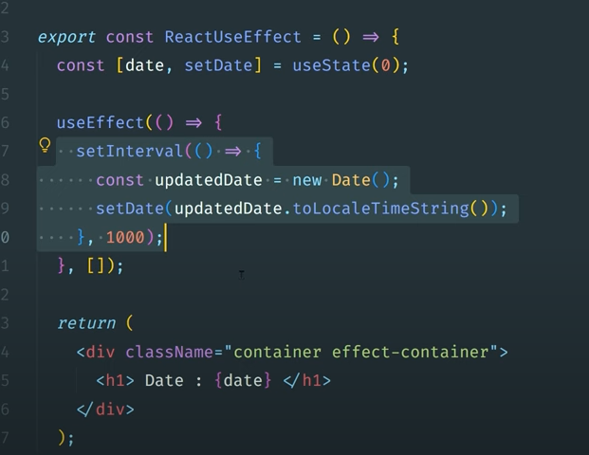

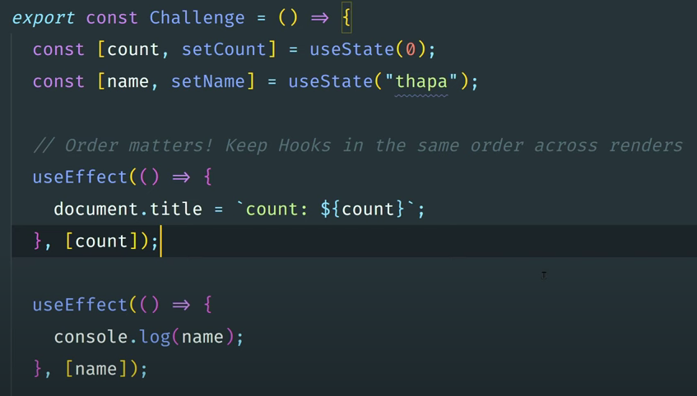

**useEffect CleanUp function**

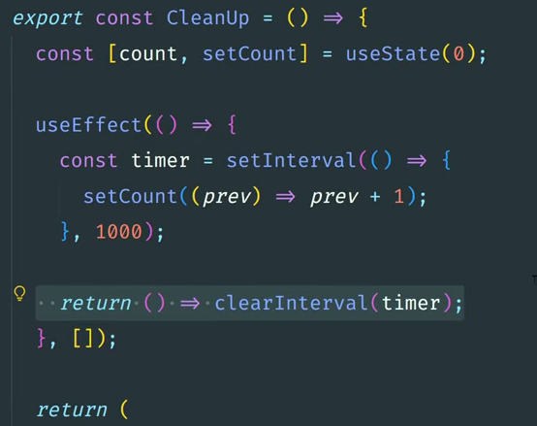

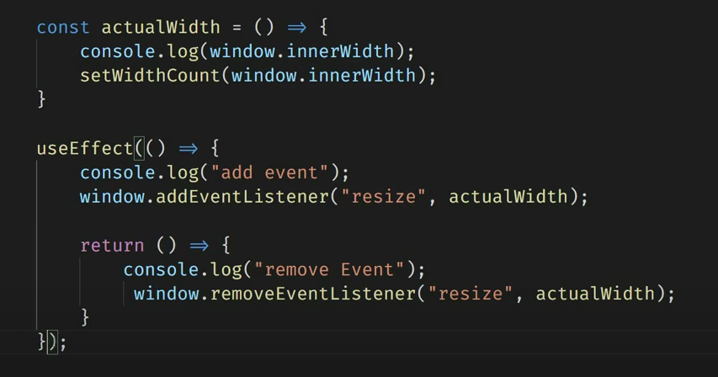

**HowNotToFetchApi**

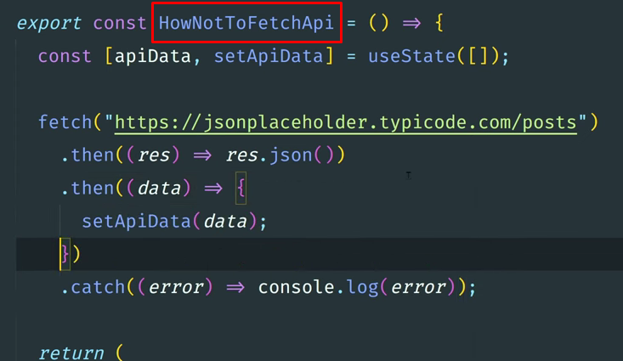

**Right way to fetch using useEffect Hook**

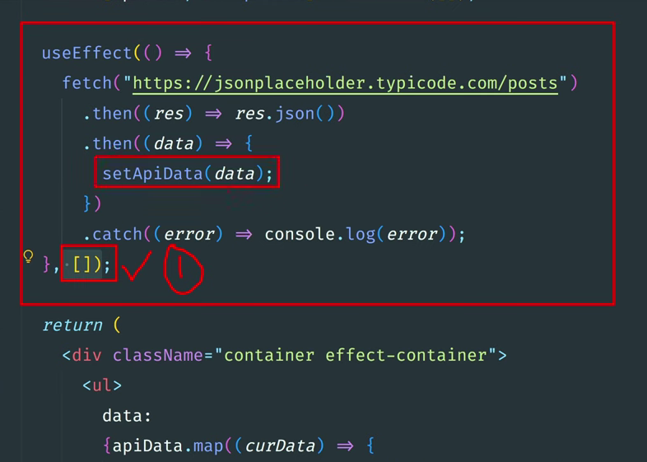

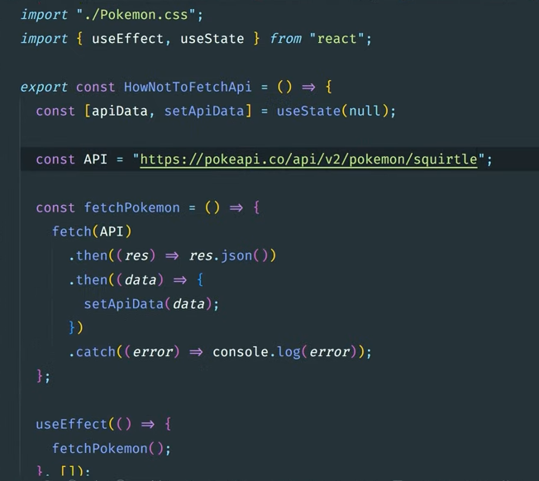

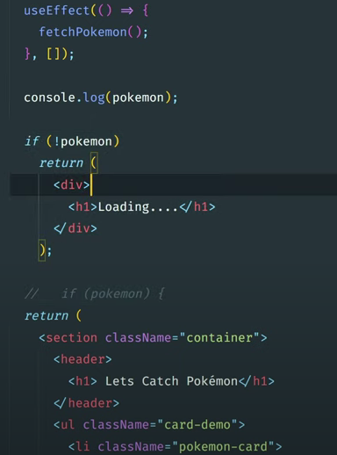

**Set and throw error while fetch data from API**

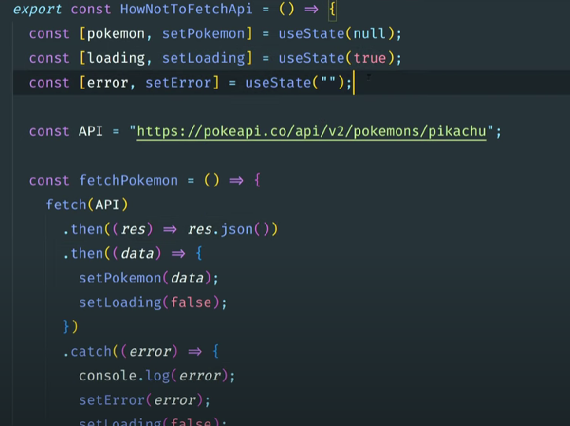

**Using Async Await method**

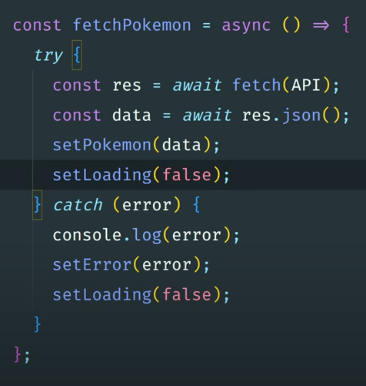

**get rid of an ESLint error**

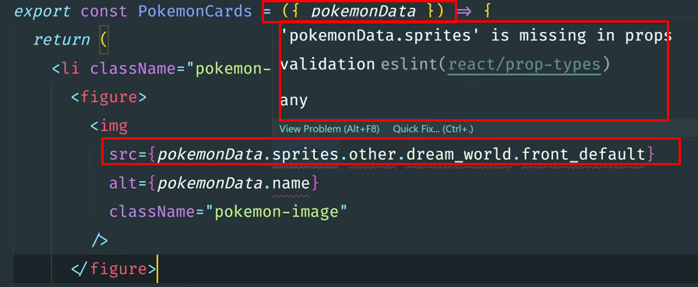

**In eslintrc.cjs add this line (screenshot below)**

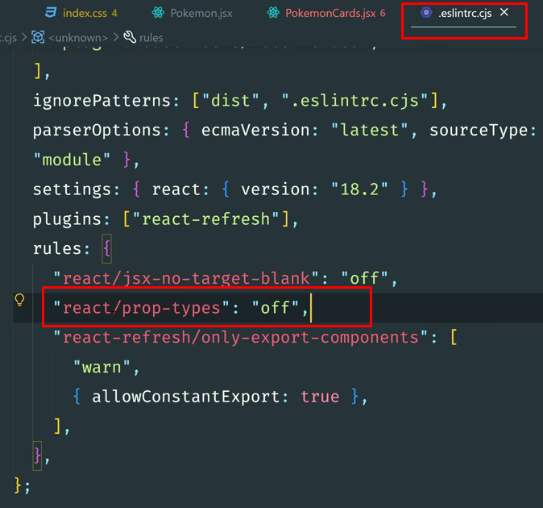

**Pokemon Api**

Preview Live URL = "<https://pokapis.netlify.app/>";

<https://pokapis.netlify.app/>

**AXIOS - Data from an API**

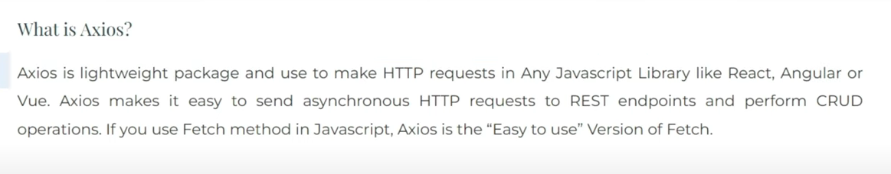

let [apiData, setApiData] = useState([]);

useEffect(() => {

let axiosInstance = axios.create({

baseURL: "https://jsonplaceholder.typicode.com/photos",

});

axiosInstance

.get("/")

.then((*response*) => {

console.log(*response*.data);

setApiData(*response*.data);

})

.catch((*error*) => {

console.error("Error fetching data:", *error*);

});

console.log(apiData);

}, []);

bun i axios

**Install bootstrap**

<https://www.npmjs.com/package/bootstrap>

npm i bootstrap

Bun i bootstrap

import 'bootstrap/dist/css/bootstrap.css';

In main.jsx 👇

import 'bootstrap/dist/css/bootstrap.css';

**Form Validation**



<https://www.npmjs.com/package/formik>

bun i formik

<https://www.npmjs.com/package/yup>

bun i yup

import {useFormik} from 'formik';

import {useFormik} from 'formik';

**Form handling with Formik**

**import { useFormik } from 'formik';**

**const initialValues = {**

**name: "",**

**email: "",**

**password: "",**

**con_password: "",**

**}**

**export const Form = () => {**

***// const Formik = useFormik({***

***// initialValues: initialValues,***

***// onSubmit: (values) => {***

***// console.log(values);***

***// }***

***// })***

***// value={Formik.values.name}***

**const { values, errors, handleBlur, handleChange, handleSubmit } = useFormik({ *//destructured***

**initialValues: initialValues,**

**onSubmit: (*values*) => {**

**console.log(*values*);**

**}**

**})**

**return (**

**<>**

**<section>**

**<div *className*="container">**

**<div *className*="row">**

**<div *className*="col-10">**

**<form *onSubmit*={handleSubmit}>**

**<div *className*="mb-3">**

**<label *htmlFor*="name" *className*="form-label">Name</label>**

**<input *type*="text" *name*='name' *className*="form-control" *id*="name" *autoComplete*='false' *value*={values.name} *onChange*={handleChange} *onBlur*={handleBlur} />**

**</div>**

**<div *className*="mb-3">**

**<label *htmlFor*="email" *className*="form-label">Email address</label>**

**<input *type*="email" *name*='email' *className*="form-control" *id*="email" *autoComplete*='false' *value*={values.email} *onChange*={handleChange} *onBlur*={handleBlur} />**

**</div>**

**<div *className*="mb-3">**

**<label *htmlFor*="password" *className*="form-label">Password</label>**

**<input *type*="password" *name*='password' *className*="form-control" *id*="password" *autoComplete*='false' *value*={values.password} *onChange*={handleChange} *onBlur*={handleBlur} />**

**</div>**

**<div *className*="mb-3">**

**<label *htmlFor*="con_password" *className*="form-label">Confirm Password</label>**

**<input *type*="con_password" *name*='con_password' *className*="form-control" *id*="con_password" *autoComplete*='false' *value*={values.con_password} *onChange*={handleChange} *onBlur*={handleBlur} />**

**</div>**

**<button *type*="submit" *className*="btn btn-primary">Submit</button>**

**</form>**

**</div>**

**</div>**

**</div>**

**</section>**

**</>**

**)**

**}**

**Create schema folder inside src folder 👇**

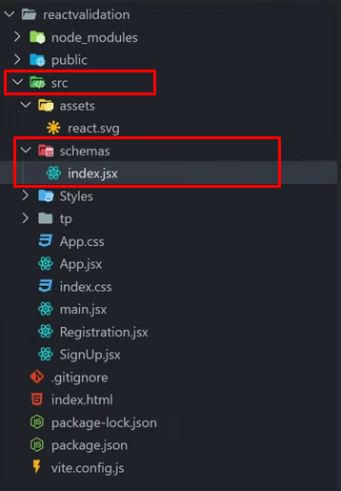

**Inside index.jsx 👇**

**import * as Yup from "yup";**

**export const signUpSchema = Yup.object({**

**name: Yup.string().min(2).max(25).required("Please enter your name"),**

**email: Yup.string().email().required("Please enter your email"),**

**password: Yup.string().min(6).required("Please enter your password"),**

**con_password: Yup.string().required().oneOf([Yup.ref("password"), null], "Password must match"),**

**});**

**Complete form.jsx 👇**

import { useFormik } from 'formik';

import { signUpSchema } from "./schema"

const initialValues = {

name: "",

email: "",

password: "",

con_password: "",

}

export const Form = () => {

*// const Formik = useFormik({*

*// initialValues: initialValues,*

*// onSubmit: (values) => {*

*// console.log(values);*

*// }*

*// })*

*// value={Formik.values.name}*

const { values, errors, handleBlur, touched, handleChange, handleSubmit } = useFormik({ *//destructured*

initialValues: initialValues,

validationSchema: signUpSchema,

validateOnChange: true,

onSubmit: (*values*, { *resetForm* }) => {

console.log(*values*);

resetForm(); *// Call resetForm to reset the form fields*

}

})

console.log(errors);

return (

<>

<section>

<div *className*="container">

<div *className*="row">

<div *className*="col-10">

<form *onSubmit*={handleSubmit}>

<div *className*="mb-3">

<label *htmlFor*="name" *className*="form-label">Name</label>

<input *type*="text" *name*='name' *className*="form-control" *id*="name" *autoComplete*='false' *value*={values.name} *onChange*={handleChange} *onBlur*={handleBlur} />

{errors.name && touched.name ? (<p>{errors.name}</p>) : null}

</div>

<div *className*="mb-3">

<label *htmlFor*="email" *className*="form-label">Email address</label>

<input *type*="email" *name*='email' *className*="form-control" *id*="email" *autoComplete*='false' *value*={values.email} *onChange*={handleChange} *onBlur*={handleBlur} />

{errors.email && touched.email ? (<p>{errors.email}</p>) : null}

</div>

<div *className*="mb-3">

<label *htmlFor*="password" *className*="form-label">Password</label>

<input *type*="password" *name*='password' *className*="form-control" *id*="password" *autoComplete*='false' *value*={values.password} *onChange*={handleChange} *onBlur*={handleBlur} />

{errors.password && touched.password ? (<p>{errors.password}</p>) : null}

</div>

<div *className*="mb-3">

<label *htmlFor*="con_password" *className*="form-label">Confirm Password</label>

<input *type*="con_password" *name*='con_password' *className*="form-control" *id*="con_password" *autoComplete*='false' *value*={values.con_password} *onChange*={handleChange} *onBlur*={handleBlur} />

{errors.con_password && touched.con_password ? (<p>{errors.con_password}</p>) : null}

</div>

<button *type*="submit" *className*="btn btn-primary">Submit</button>

</form>

</div>

</div>

</div>

</section>

</>

)

}

**Code Spell Checker 👇**

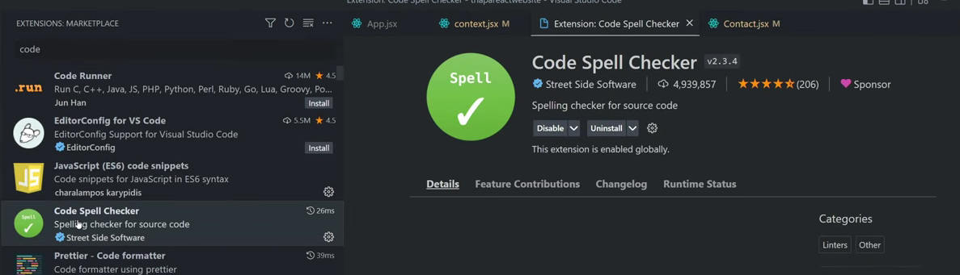

**Turbo Console log👇**

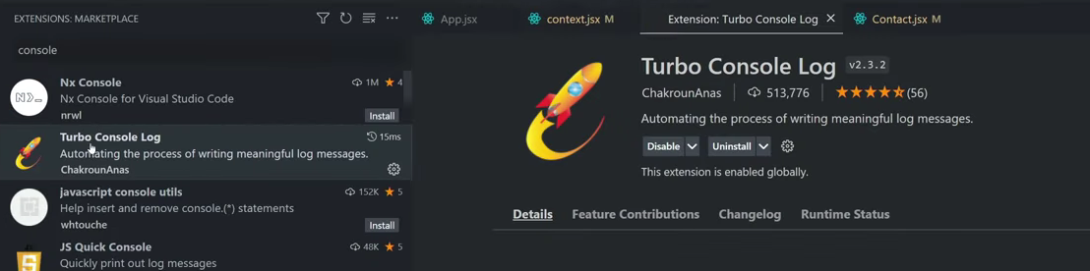

**CTRL + ALT + L**

**Swiper slider breakpoints**

Swiper Breakpoints

import life from "/images/life.jpeg";

import lilly from "/images/lilly.jpeg";

import myob from "/images/myob.jpeg";

import oldendroff from "/images/oldendroff.jpeg";

import trustly from "/images/trustly.jpeg";

import citrus from "/images/citrus.jpeg";

import grabyo from "/images/grabyo.jpeg";

import belimo from "/images/belimo.jpeg";

import { Swiper, SwiperSlide } from "swiper/react";

import "swiper/css";

import "swiper/css/autoplay";

import { Autoplay } from "swiper/modules";

import Common from "./Common";

const com = {

padding: "40px",

};

const Carousel = () => {

return (

<Swiper

spaceBetween={50}

slidesPerView={5}

autoplay={{

delay: 1000,

disableOnInteraction: false,

}}

modules={[Autoplay]}

onSlideChange={() => console.log("slide change")}

onSwiper={(swiper) => console.log(swiper)}

breakpoints={{

// when window width is >= 640px

0: {

slidesPerView: 1,

},

576: {

slidesPerView: 2,

},

*// when window width is >= 768px*

768: {

slidesPerView: 3,

},

*// when window width is >= 1024px*

1024: {

slidesPerView: 4,

},

*// when window width is >= 1280px*

1280: {

slidesPerView: 5,

},

}}

>

<SwiperSlide style={com}>

<Common imgsrc={life} />

</SwiperSlide>

<SwiperSlide style={com}>

<Common imgsrc={grabyo} />

</SwiperSlide>

<SwiperSlide style={com}>

<Common imgsrc={lilly} />

</SwiperSlide>

<SwiperSlide style={com}>

<Common imgsrc={myob} />

</SwiperSlide>

<SwiperSlide style={com}>

<Common imgsrc={belimo} />

</SwiperSlide>

<SwiperSlide style={com}>

<Common imgsrc={citrus} />

</SwiperSlide>

<SwiperSlide style={com}>

<Common imgsrc={oldendroff} />

</SwiperSlide>

<SwiperSlide style={com}>

<Common imgsrc={trustly} />

</SwiperSlide>

</Swiper>

);

};

export default Carousel;

**Class base component**

import React, { Component } from 'react';

class Counter extends Component {

constructor(*props*) {

*super*(*props*);

this.state = {

count: 0

};

}

increment = () => {

this.setState((*prevState*) => ({

count: *prevState*.count + 1

}));

};

render() {

return (

<div>

<h1>*Count*: {this.state.count}</h1>

<button onClick={this.increment}>Increment</button>

</div>

);

}

}

export default Counter;

**React Ionicons**

npm i react-ionicons

https://react-ionicons.netlify.app/

.

https://techmind.co.in/react_websites/app name/folder/imagename

Tags ko as a text print issue ayega to

ye attribute set krna

dangerouslySetInnerHTML={{ __html: props.heading }}

<h3

className="hdng fs_64 mb_60"

dangerouslySetInnerHTML={{ __html: props.heading }}

></h3>